BHAVAN’S VIVEKANANDA COLLEGE of
Science, Humanities and Commerce
Reaccredited with ‘A’ grade by NAAC
Autonomous College
(Affiliated to Osmania University)
SAINIKPURI, SECUNDERABAD



Project Report
On
SMART CROP CARE
V.Narsimha – 107222468031 – B.Sc. MPCs 3A

Bhavan’s Vivekananda College
of Science, Humanities & Commerce,
Sainikpuri, Secunderabad – 500094
(Reaccredited with ‘A ’grade by NAAC)
Autonomous College - Affiliated to Osmania University
CERTIFICATE
This is to certify that Voggu Narsimha bearing Roll No: 10722248031 student of B.Sc. III Yr has carried out a research project titled SMART CROP CARE from the Department of Computer Science, Bhavan’s Vivekananda College of Science, Humanities and Commerce, Sainikpuri, Secunderabad.

ACKNOWLEDGEMENT

My Project “Smart Crop Care”, would be incomplete without expressing our thanks to all those who have helped me in completing this project
I would also like to thank our Principal, Prof. Dr.G.S.V.R.K.CHOUDARY for giving us this golden opportunity to work on this project. I had always got enough support and encouragement from him.
I would like to express our sincere thanks to Padma Priya Ma’am., Head of the Department and I will let you this name here. , Assistant Professors, Department of Computer Science, who have been guiding me throughout my study. They have been with me during the project, and always gave me the right piece of advice. It is with their support and guidance that today I could complete this project.
I would like to thank all our seniors who guided me always and were very welcoming for any sort of questions and issues, and helped me every time I approached.

ABOUT ORGANISATION

Bhavan's Vivekananda College of Science, Humanities and Commerce was founded in 1993 under the aegis of the Bharatiya Vidya Bhavan. Ever since its inspection, the college has been providing quality education to all students in large variety of courses. The college continues to provide all students a solid foundation for further educational opportunities and the skill for various career opportunities upon graduation.
The college offers a peaceful atmosphere which is ideal for academic pursuits and for the overall development of the students. The college seeks to integrate the student's programme of study and the development of skills which includes critical thinking, problem solving, written and oral communication and encouraging research techniques in various fields. It seeks to learn, to adapt and to lead in the creation of a pool of committed and competent individuals indicated to the process of nation building.
The college has a dedicated set of staff, lecturers and support staff. The lecturers, apart from teaching, also imbibe principles of discipline, commitment and hard work and to strive towards achieving the goals. They support the students in all possible ways and help students to solve their various problems and encourage the students to perform well in both academics and other co-curricular activities.
Overall, the college, with its holistic atmosphere aided for learning, the principles and values that are imbibed into the students, the excellent staff headed by an able and strong Principle dedicated to making the students the citizens of the future, Bhavan's Vivekananda College of Science, Humanities and Commerce is the college, where we enter in as students and pass out as molded and well-read persons, ready to take on the challenges that come by us in the future

ABSTRACT

The Smart Crop Care project is an AI-driven Expo React Native application designed to empower farmers by integrating technology into agriculture. This app provides farmers with essential tools to access agricultural news, real-time weather updates, disease detection, fertilizer recommendations, customer support, and an online store—all in one place.
Many farmers struggle with unpredictable weather conditions, crop diseases, and accessing necessary resources like fertilizers and agricultural news. Smart Crop Care solves these challenges by offering a user-friendly mobile application that provides accurate weather forecasts, AI-powered crop disease detection, and seamless access to fertilizers and support services.
Proposed System:

The Smart Crop Care app ensures farmers can:
✔ Receive real-time agricultural news and weather updates.
✔ Detect crop diseases using AI technology.
✔ Get recommendations for the best fertilizers for their crops.
✔ Access customer support for expert guidance.
✔ Purchase agricultural products through an integrated online store.

The proposed system is a mobile application, making it accessible on both Android device and IOS anytime, anywhere. By leveraging AI and digital solutions, Smart Crop Care revolutionizes the way farmers interact with technology, improving productivity and efficiency in modern agriculture.

HARDWARE AND SOFTWARE REQUIREMENTS

HARDWARE REQUIREMENT:
RAM Size : 4GB RAM
Processor : Intel i5 processor

SOFTWARE REQUIREMENTS:

Operating System : Android 5
Front End Software : Expo react native
Backend Language : Firebase

TECHNOLOGIES USED

Introduction

Smart Crop Care is an AI-driven Expo React Native application designed to assist farmers by providing technology-based solutions. The app includes features such as weather reports, agriculture news, disease detection, fertilizers, customer support, and an online store. The primary goal of the application is to empower farmers by giving them access to real-time information that helps them make informed decisions.

Development Framework

The project is developed using React Native, which allows the application to run seamlessly on both Android and iOS devices. By utilizing Expo Go, developers and users can preview the app instantly on mobile devices without the need for complex builds. React Native ensures a smooth user experience by providing a native-like performance while using JavaScript for the front end.

Backend and Database

For backend services and data storage, Firebase is used. Firebase provides a cloud-based backend, including features such as authentication, real-time database, and storage solutions, which are essential for handling user data, application states, and other dynamic content. It eliminates the need for setting up and managing traditional backend infrastructure, allowing for efficient development and scalability.

APIs Used in Smart Crop Care
To enhance functionality and provide real-time agricultural data, multiple APIs are integrated into the application:
- Plant API for Disease Detection:
  - This API is used to analyse plant images and detect diseases based on machine learning models.
  - Farmers can upload pictures of their crops, and the AI-driven system will identify possible diseases and suggest solutions.
- GNews API for Agriculture News:
  - The GNews API is used to fetch real-time agriculture-related news from various sources.
  - This ensures that farmers stay updated with the latest industry trends, government policies, and best farming practices.
- Tomorrow.io API for Weather Forecasts:
  - This API provides real-time and future weather predictions.
  - Weather conditions are crucial for farming, and this integration helps farmers plan their activities based on temperature, rainfall, humidity, and other climatic factors.

\

Key Features Powered by Technology

- Weather Report: Helps farmers prepare for changing weather conditions using the Tomorrow.io API.
- Agriculture News: Keeps farmers informed about the latest agricultural updates via the GNews API.
- Disease Detection: Uses Plant API to identify plant diseases and recommend treatment options.
- Fertilizer Information: Provides information about suitable fertilizers for different crops.
- Customer Support: Offers direct assistance to farmers with queries regarding agricultural practices.
- Online Store: Enables farmers to buy fertilizers, seeds, and farming equipment from a digital marketplace.

Conclusion

Smart Crop Care is a feature-rich application that brings the power of AI and cloud computing to agriculture. By leveraging technologies like React Native, Firebase, and third-party APIs, the application ensures farmers have access to critical agricultural data anytime, anywhere. The seamless integration of multiple services helps improve decision-making, enhance productivity, and make farming more efficient and sustainable.

React Native and Expo: Technologies Powering Smart Crop Care

Introduction

React Native and Expo play a crucial role in the development of Smart Crop Care, an AI-driven mobile application designed to assist farmers by leveraging modern technology. The application is built using React Native for cross-platform compatibility and Expo to streamline development and testing processes. This document provides an overview of these technologies and how they contribute to the functionality of Smart Crop Care.

What is React Native?

React Native is a popular open-source framework developed by Meta (formerly Facebook) that enables developers to build mobile applications using JavaScript and React. Unlike traditional mobile development approaches that require separate codebases for Android and iOS, React Native allows developers to write a single codebase that runs efficiently on both platforms.

Key Features of React Native:

- Cross-Platform Development: Enables the same codebase to be used for both Android and iOS, reducing development time and effort.
- Hot Reloading: Allows developers to see changes instantly without recompiling the entire application.
- Performance Optimization: Uses native components to ensure smooth and responsive user interfaces.
- Large Community Support: A vast ecosystem of third-party libraries and plugins enhances development flexibility.

What is Expo?
Expo is an open-source platform that simplifies the development and testing of React Native applications. It provides a set of tools and services that enhance the efficiency of the development process by eliminating the need to manage native code.

Key Features of Expo:

- Expo Go: Allows developers to preview the app on a physical device without the need for compiling or building APK/IPA files.
- Simplified Development Process: Provides pre-built libraries and APIs for handling device functionalities like the camera, notifications, and location.
- Over-the-Air (OTA) Updates: Enables developers to push updates to the app without requiring users to download a new version from the app store.
- Easy Deployment: Supports quick publishing to Google Play Store and Apple App Store.

Why Use React Native and Expo for Smart Crop Care?
1. Cross-Platform Compatibility: Since Smart Crop Care needs to be accessible to farmers using both Android and iOS devices, React Native ensures seamless operation on both platforms with a single codebase.
2. Faster Development and Deployment: Expo provides tools like Expo Go, which helps test the application in real time on mobile devices without requiring complex builds.
3. Integration with APIs: React Native and Expo make it easy to integrate essential APIs such as:
- Plant API for disease detection
- GNews API for real-time agriculture news
- Tomorrow.io API for weather forecasting
4. Smooth Performance: React Native uses native modules for better efficiency, ensuring the app remains lightweight and fast.

React Native and Expo provide a powerful combination for developing mobile applications efficiently. With React Native's cross-platform capabilities and Expo's streamlined development tools, Smart Crop Care successfully delivers real-time agricultural solutions to farmers. By leveraging these technologies, the application ensures an optimal user experience, quick updates, and seamless API integrations, making farming more data-driven, efficient, and sustainable.

SYSTEM ANALYSIS PURPOSE OF THE SYSTEM

Introduction
The Smart Crop Care application is designed to empower farmers by leveraging AI-driven technology to improve agricultural practices. The app provides farmers with real-time weather updates, the latest agricultural news, disease detection for crops, access to fertilizers, and customer support. By integrating advanced technologies, Smart Crop Care aims to make farming more efficient, productive, and sustainable.

Purpose of the System
1. Providing Real-Time Weather Updates
Farmers rely heavily on weather conditions to make informed decisions regarding irrigation, planting, and harvesting. The app uses Tomorrow.io API to deliver accurate and up-to-date weather forecasts, helping farmers plan their activities efficiently.
2. Access to Agricultural News
Staying informed about the latest developments in the agricultural sector is crucial for farmers. Smart Crop Care integrates the GNews API to provide real-time updates on farming techniques, government policies, and market trends.
3. AI-Based Crop Disease Detection
One of the core features of Smart Crop Care is its AI-driven disease detection system. Using Plant API, farmers can upload images of their crops, and the system analyzes them to identify potential diseases, offering recommendations for treatment and prevention.
4. Easy Access to Fertilizers and Inputs
The app includes an online store where farmers can browse and purchase necessary fertilizers, pesticides, and other agricultural inputs. This feature ensures that farmers have easy access to quality products without the need to travel long distances.

Technology Stack Used
The application is built using modern technologies to ensure scalability and ease of use:
- React Native: A JavaScript framework for cross-platform mobile development.
- Expo: A tool that simplifies development, testing, and deployment.
- Firebase: Used for backend services, including authentication and database management.
- APIs Used:
  - Tomorrow.io API for weather reports.
  - GNews API for agriculture-related news.
  - Plant API for disease detection in crops.

Conclusion
The Smart Crop Care application revolutionizes farming by integrating AI and technology to provide essential services at farmers' fingertips. By offering weather updates, disease detection, news, and an online store, the app ensures that farmers can make informed decisions, increase productivity, and improve overall agricultural efficiency.

FEASIBILITY REPORT

- Technical Feasibility

The Smart Crop Care application is developed using modern and well-supported technologies, ensuring its feasibility for implementation. The app is built using React Native, which allows seamless cross-platform functionality on both Android and iOS devices
2. Operational Feasibility
The application is designed with a user-friendly interface, ensuring that farmers can easily access and utilize its features. The system provides real-time weather updates, news, disease detection, fertilizer purchase options, and customer support, all of which contribute to the efficiency of farming operations. The AI-driven disease detection feature simplifies identifying and treating crop-related issues, making the app highly beneficial to farmers.
3. Economic Feasibility
The development of Smart Crop Care is cost-effective due to the use of open-source frameworks and cloud-based services. The primary costs are associated with API subscriptions, Firebase services, and maintenance. However, these costs are outweighed by the benefits of increased agricultural productivity, reduced crop losses, and improved decision-making for farmers. Additionally, the app can generate revenue through premium features, advertisements, and partnerships with agricultural suppliers.
4. Social and Environmental Feasibility
The application supports sustainable farming by providing accurate weather predictions, reducing dependency on chemical pesticides through precise disease detection, and enabling informed decision-making. By digitizing essential farming resources, Smart Crop Care reduces the need for physical travel, minimizing carbon footprints and contributing to environmental conservation. Socially, the app empowers farmers with technology, bridging the gap between rural communities and modern agricultural advancements.
Coding:

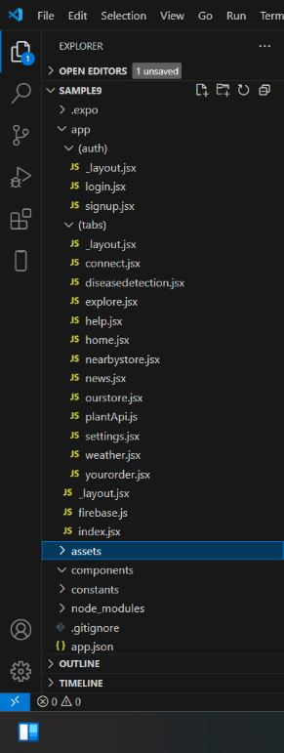

APP>LAYOUT-PAGE

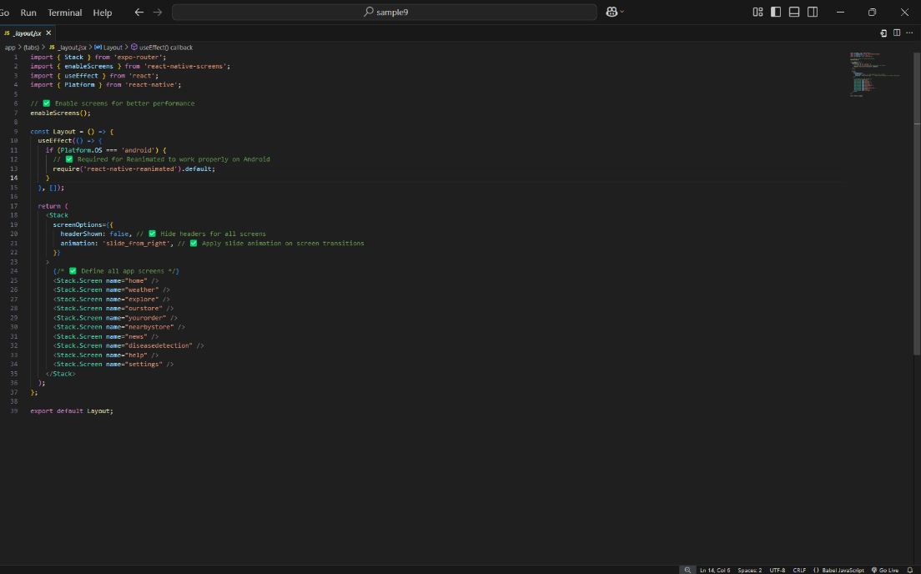

After that create two files in the APP folder that are (auth), (tabs). In Auth folder create three separate folders they are signup, login and layout

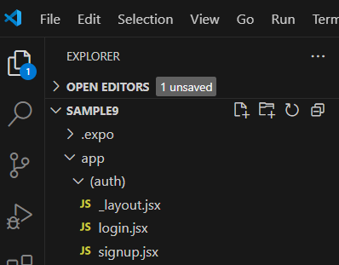

Layout page code! => _layout.jsx

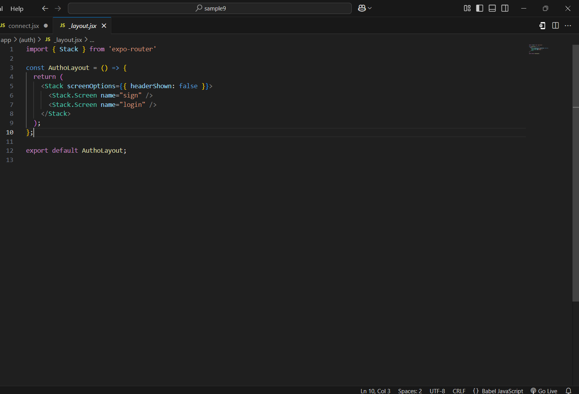

Signup page!=> signup.jsx
`
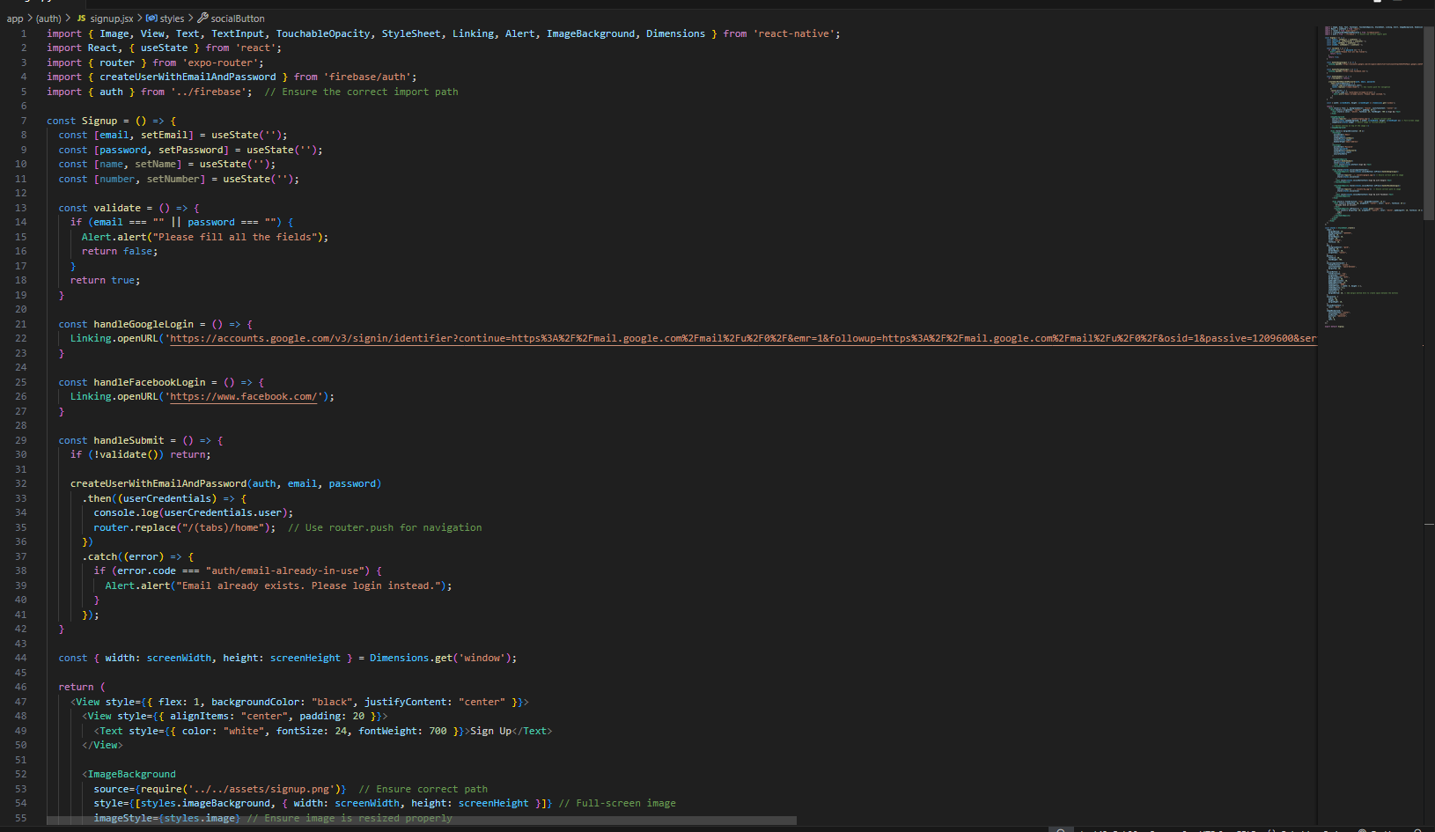
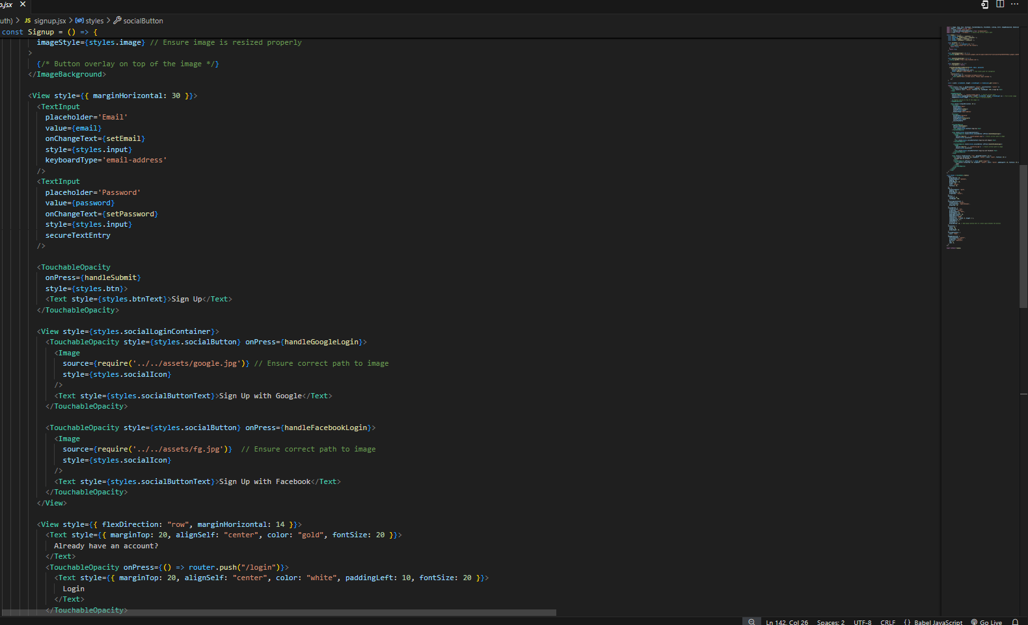
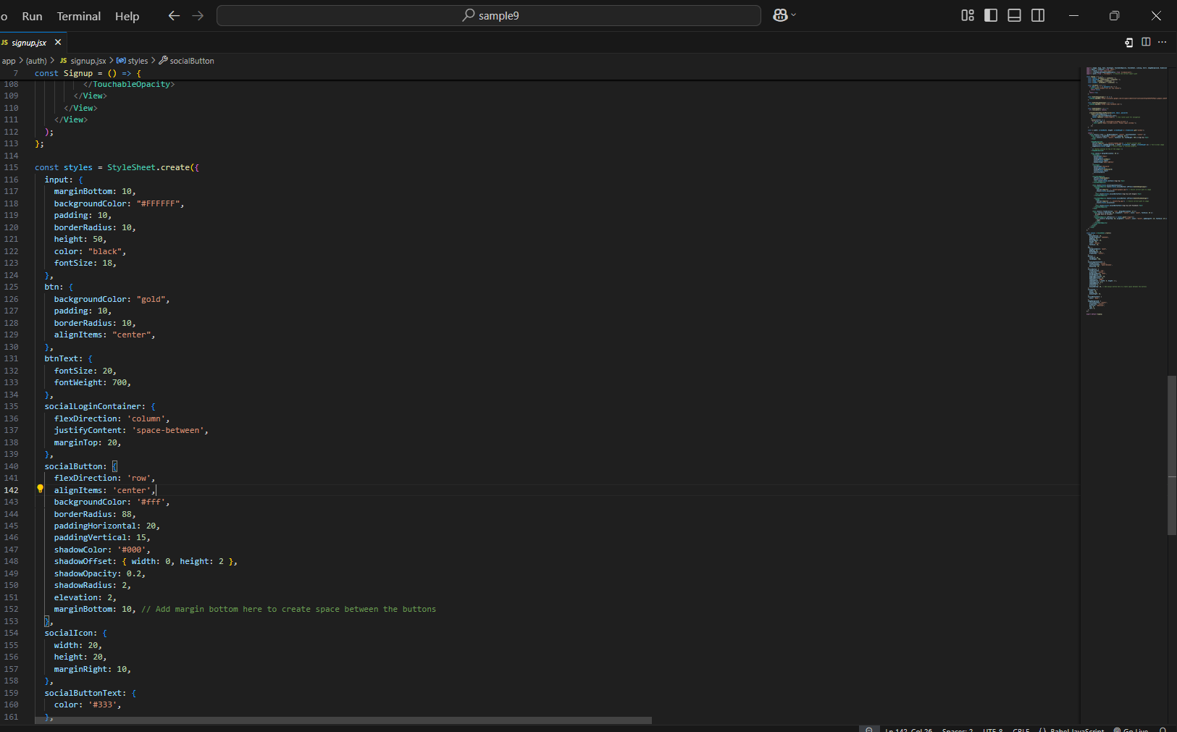

Login page code! =>login page

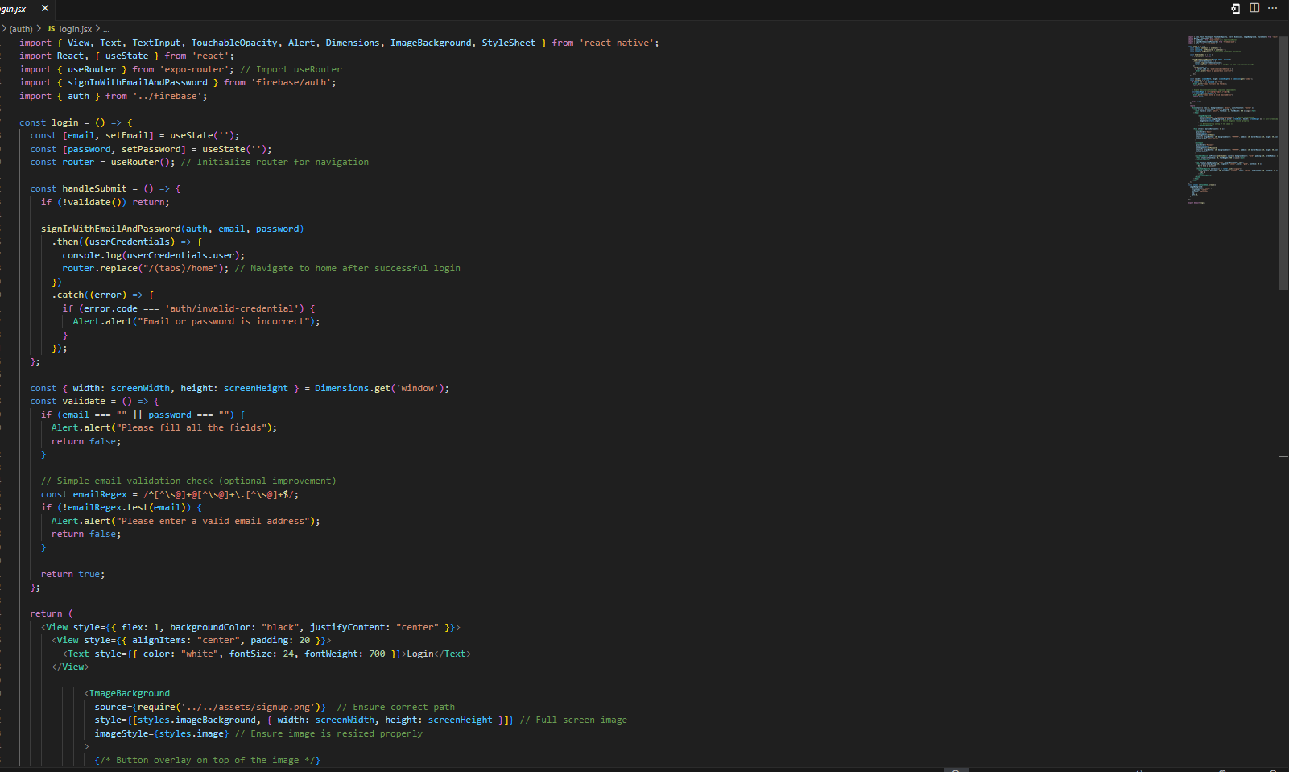
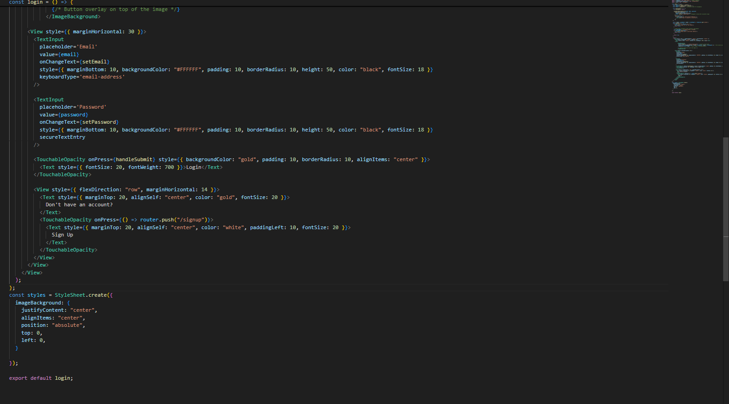

After that create one more folder (tabs)!
>app>(tabs)>home //=>home.jsx

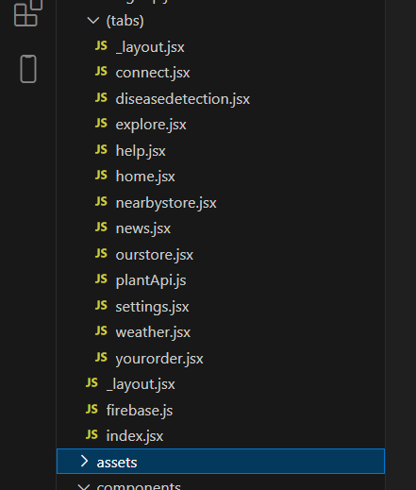

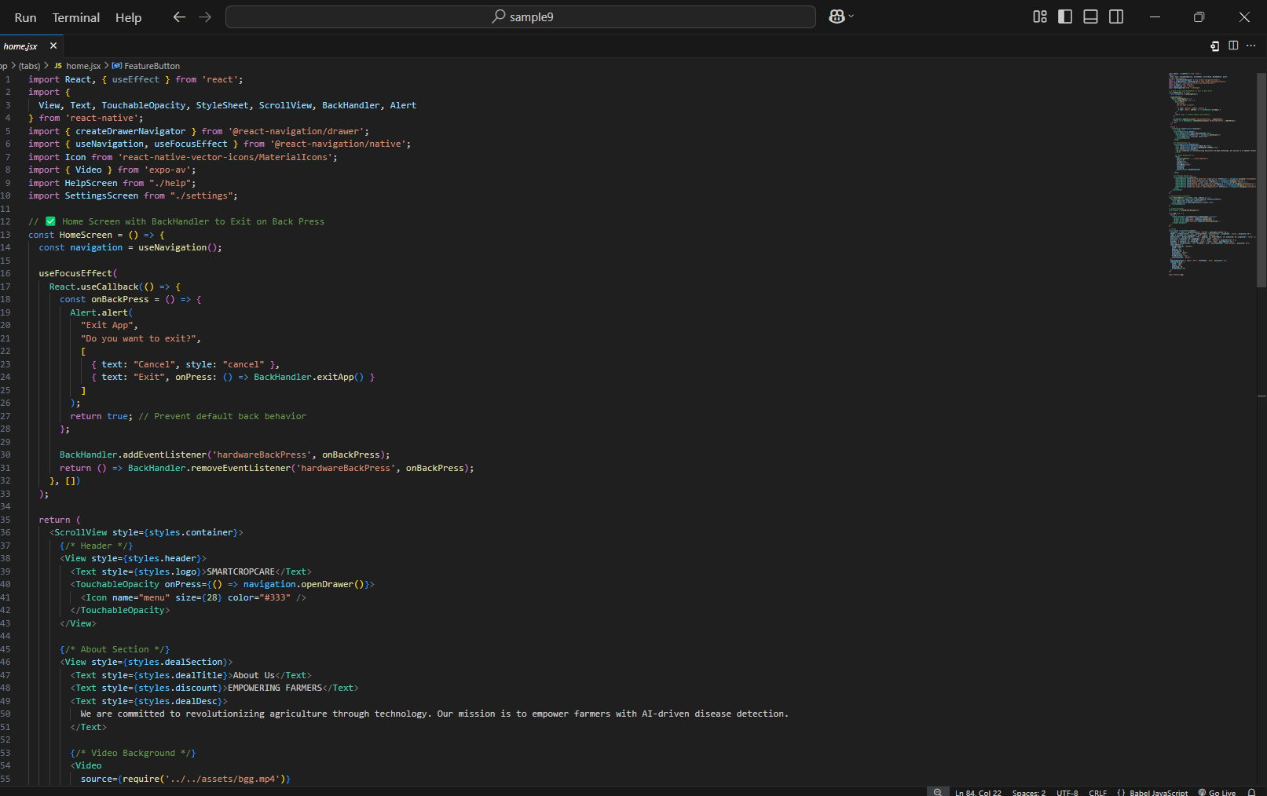

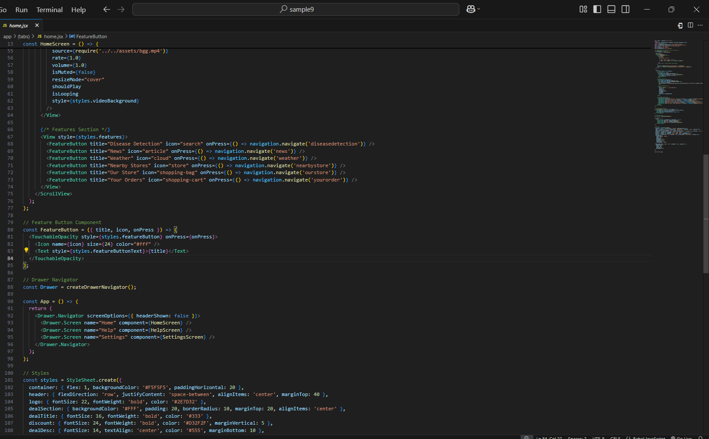
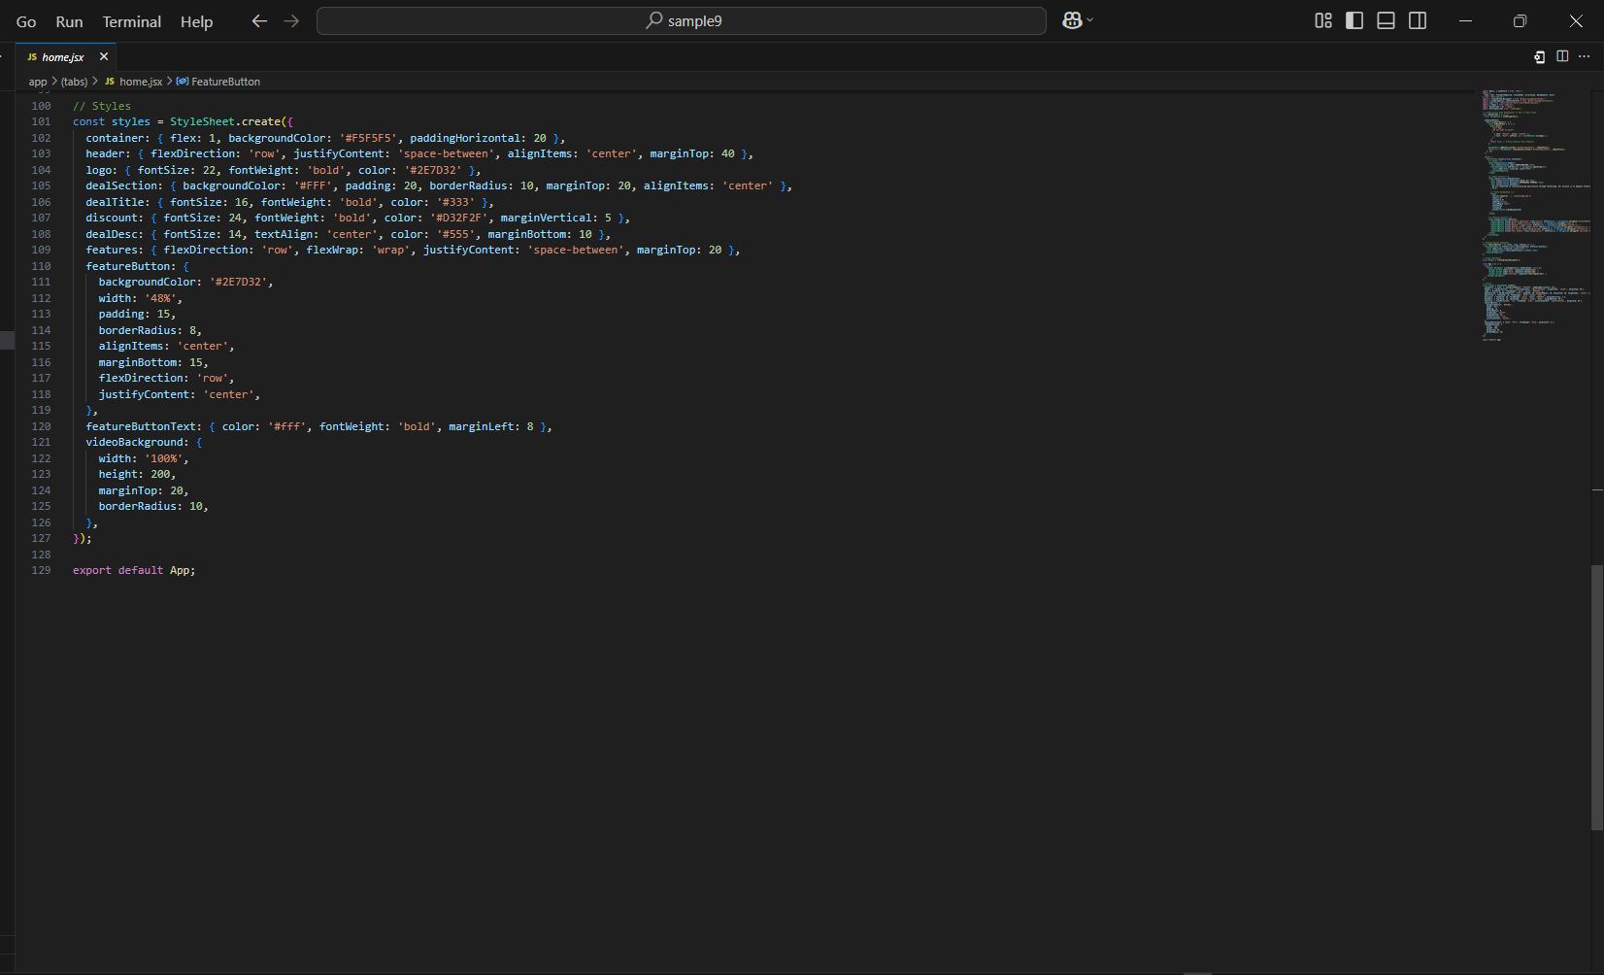

After that create different pages!

Disease Detection:

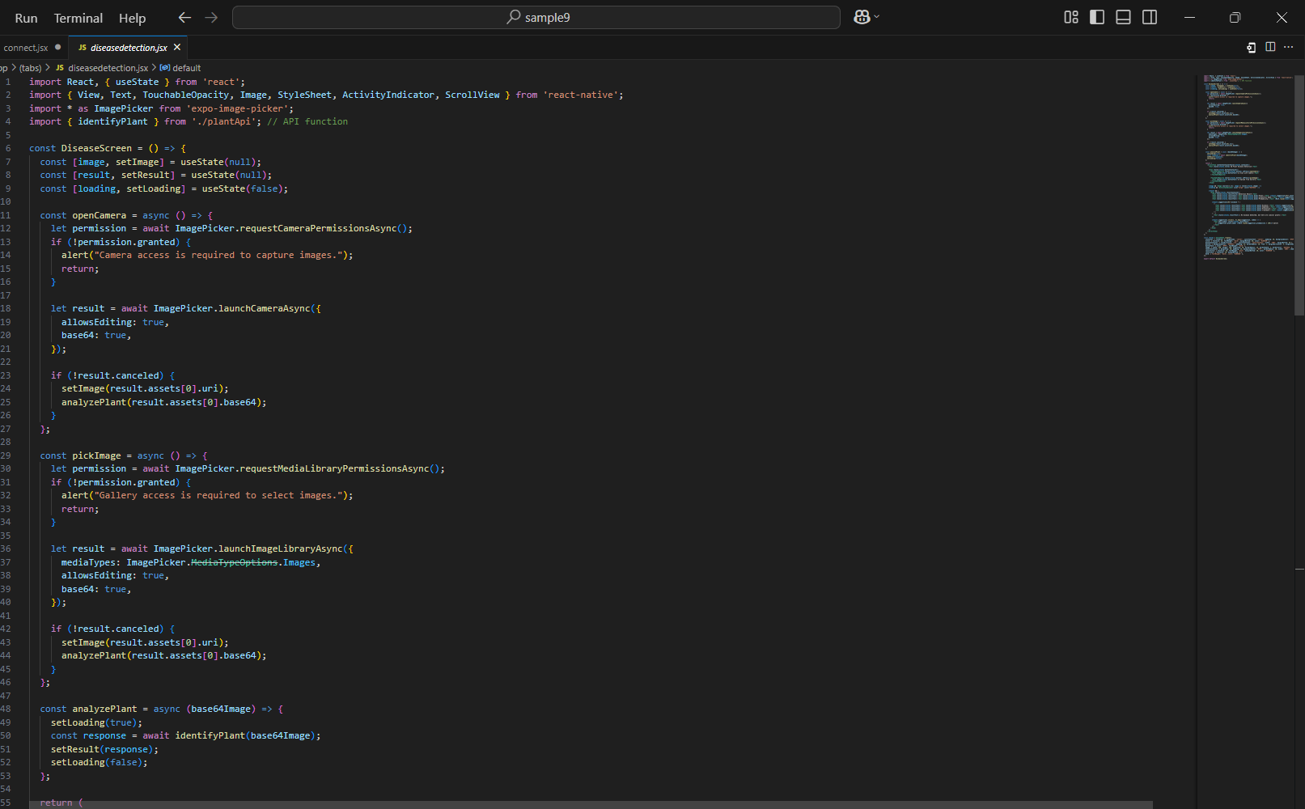
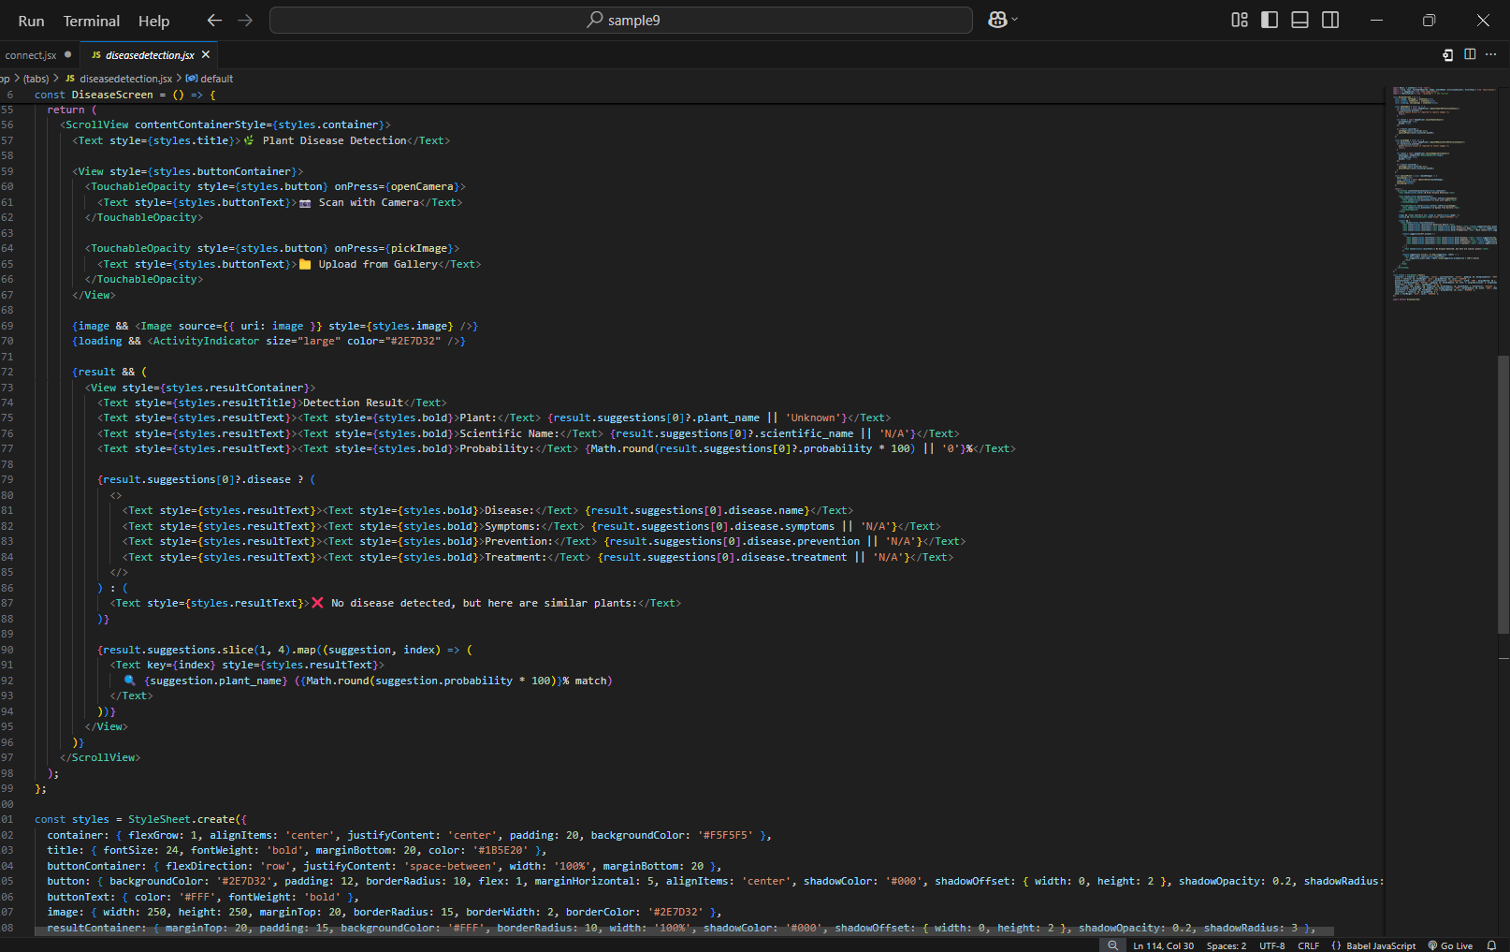

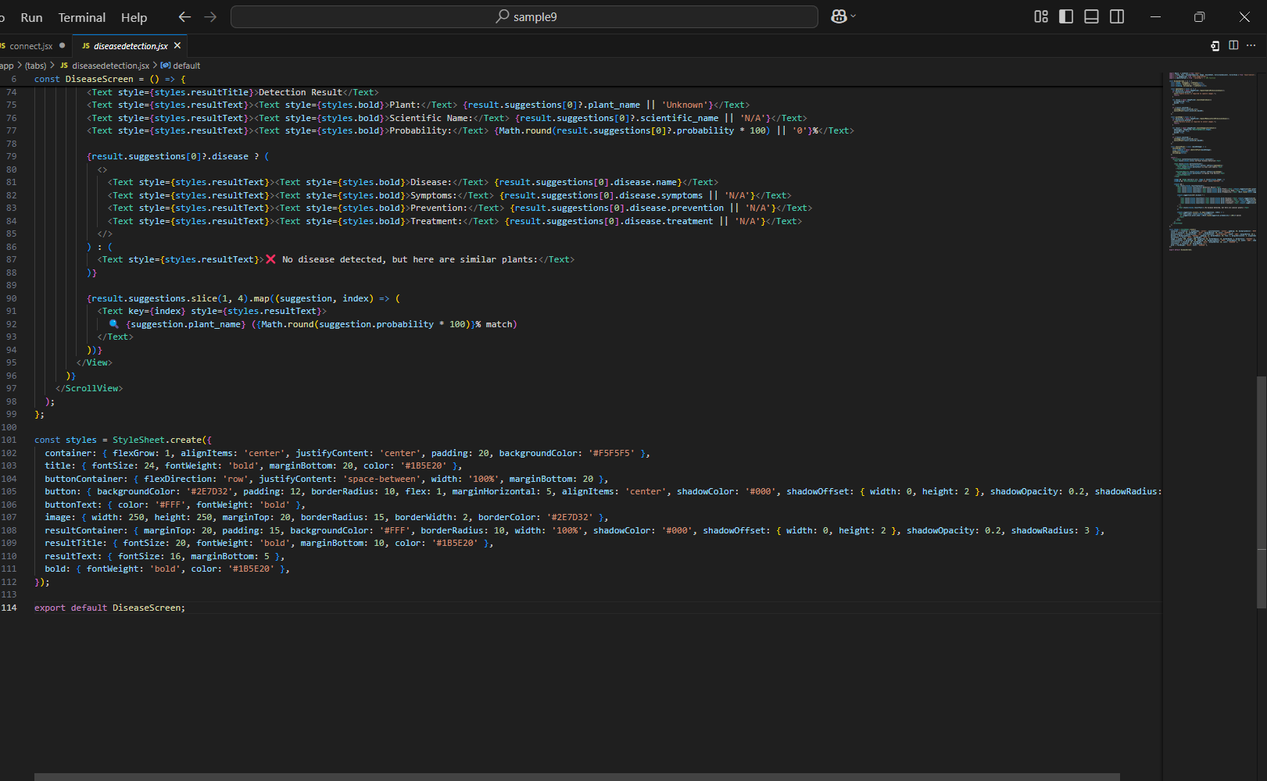

News pages!

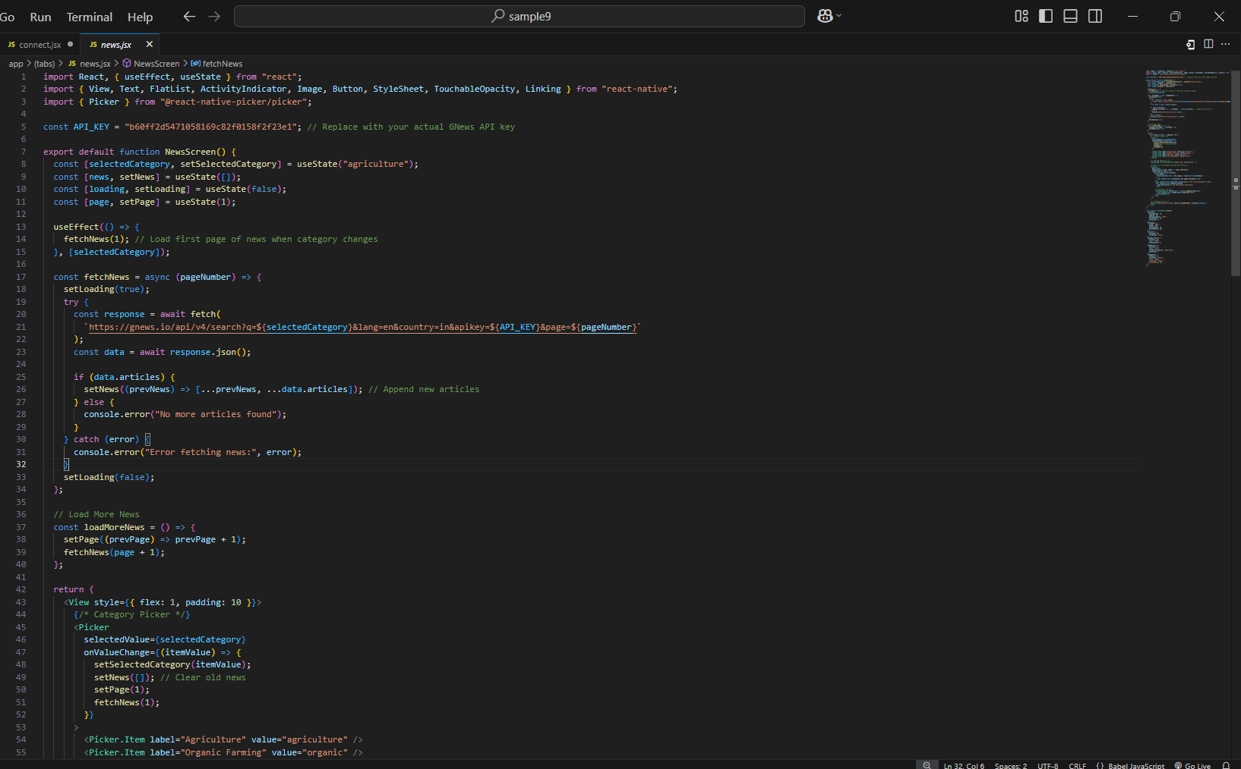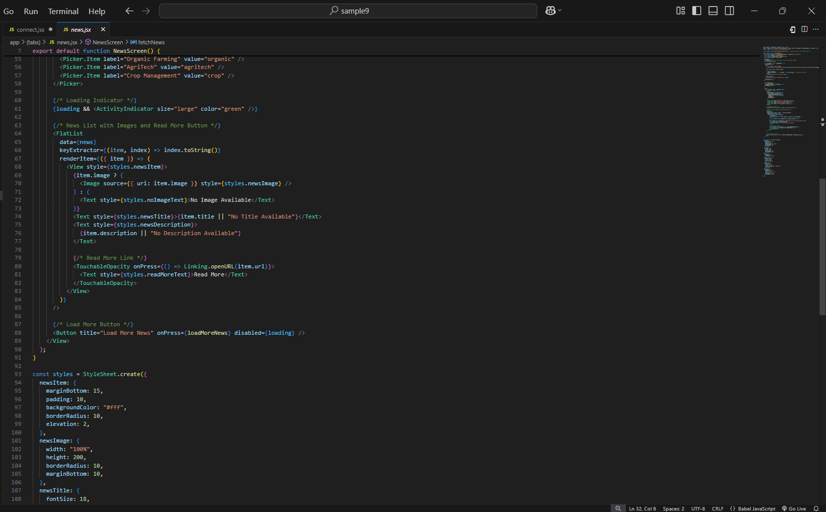
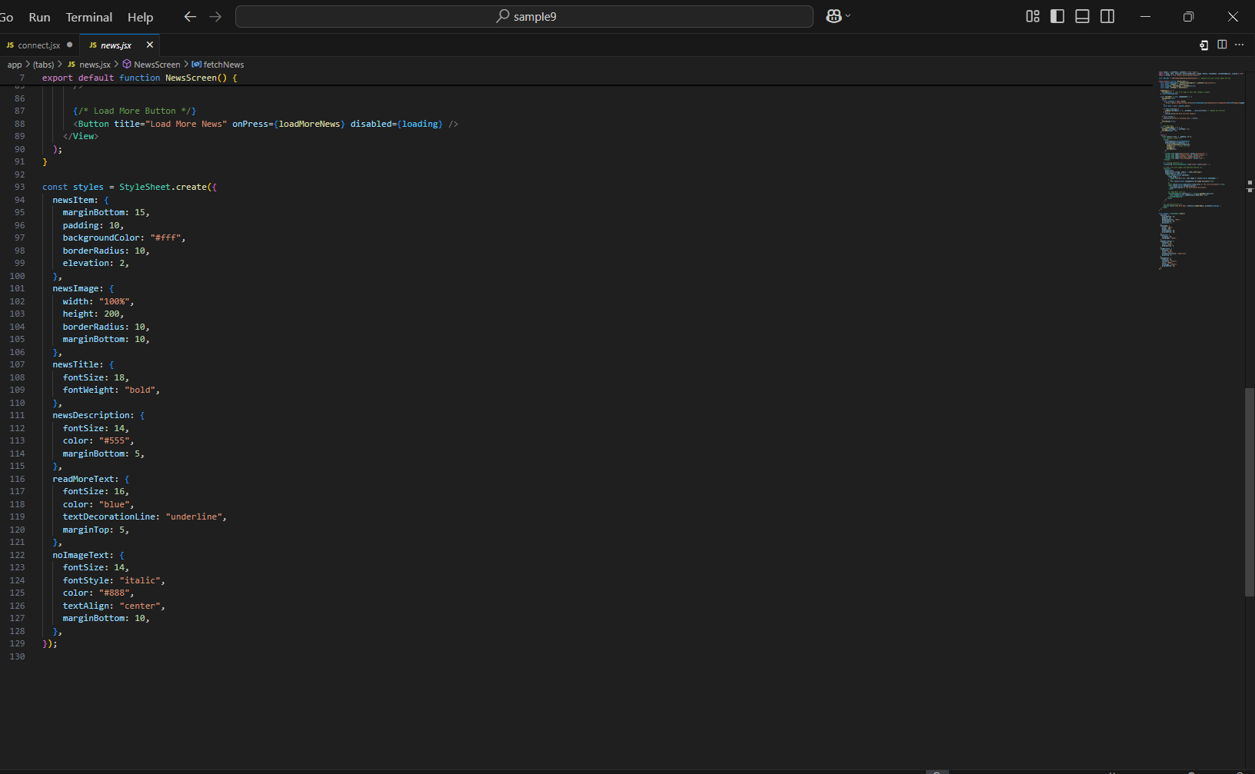

Weather.jsx page!

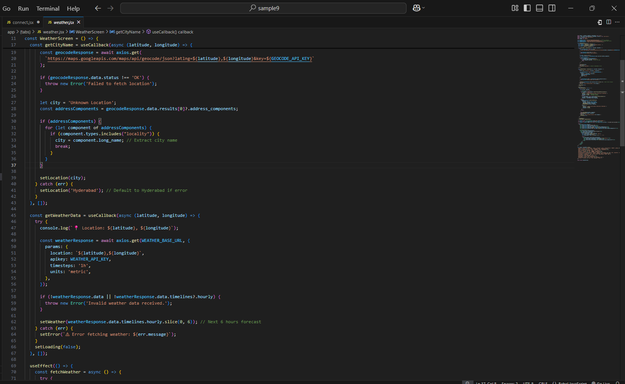
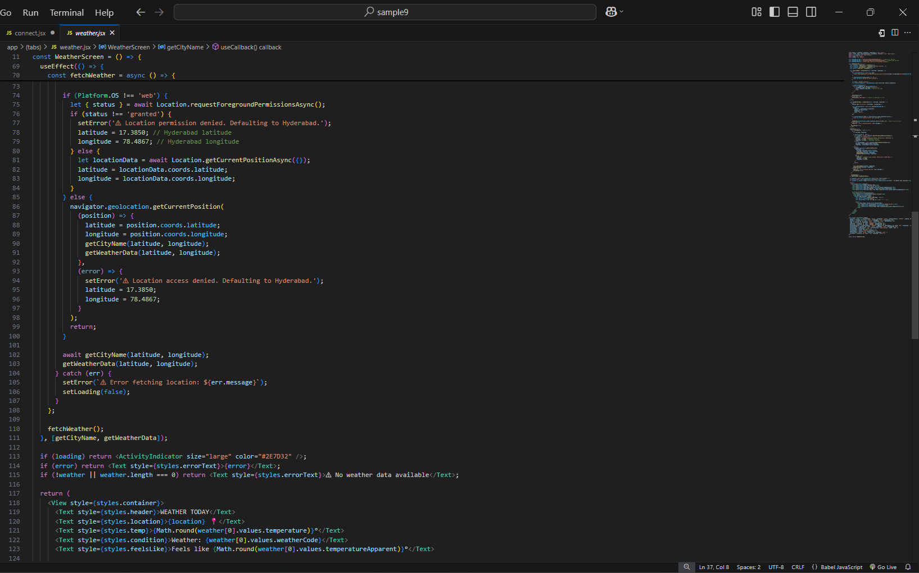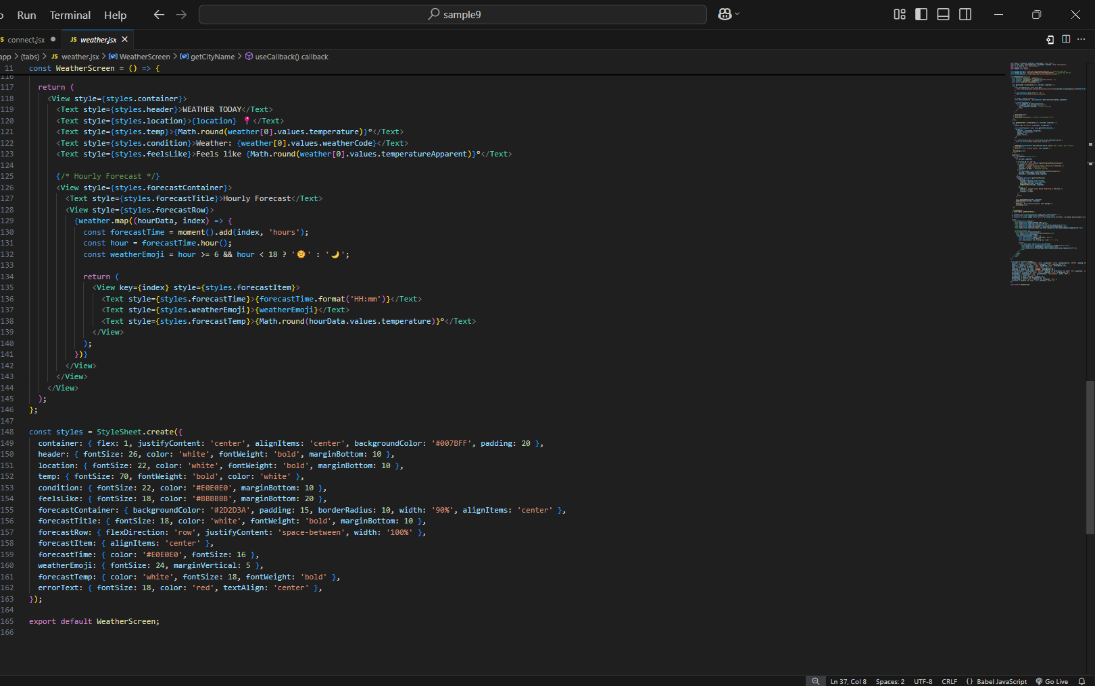

Our Store.jsx page!

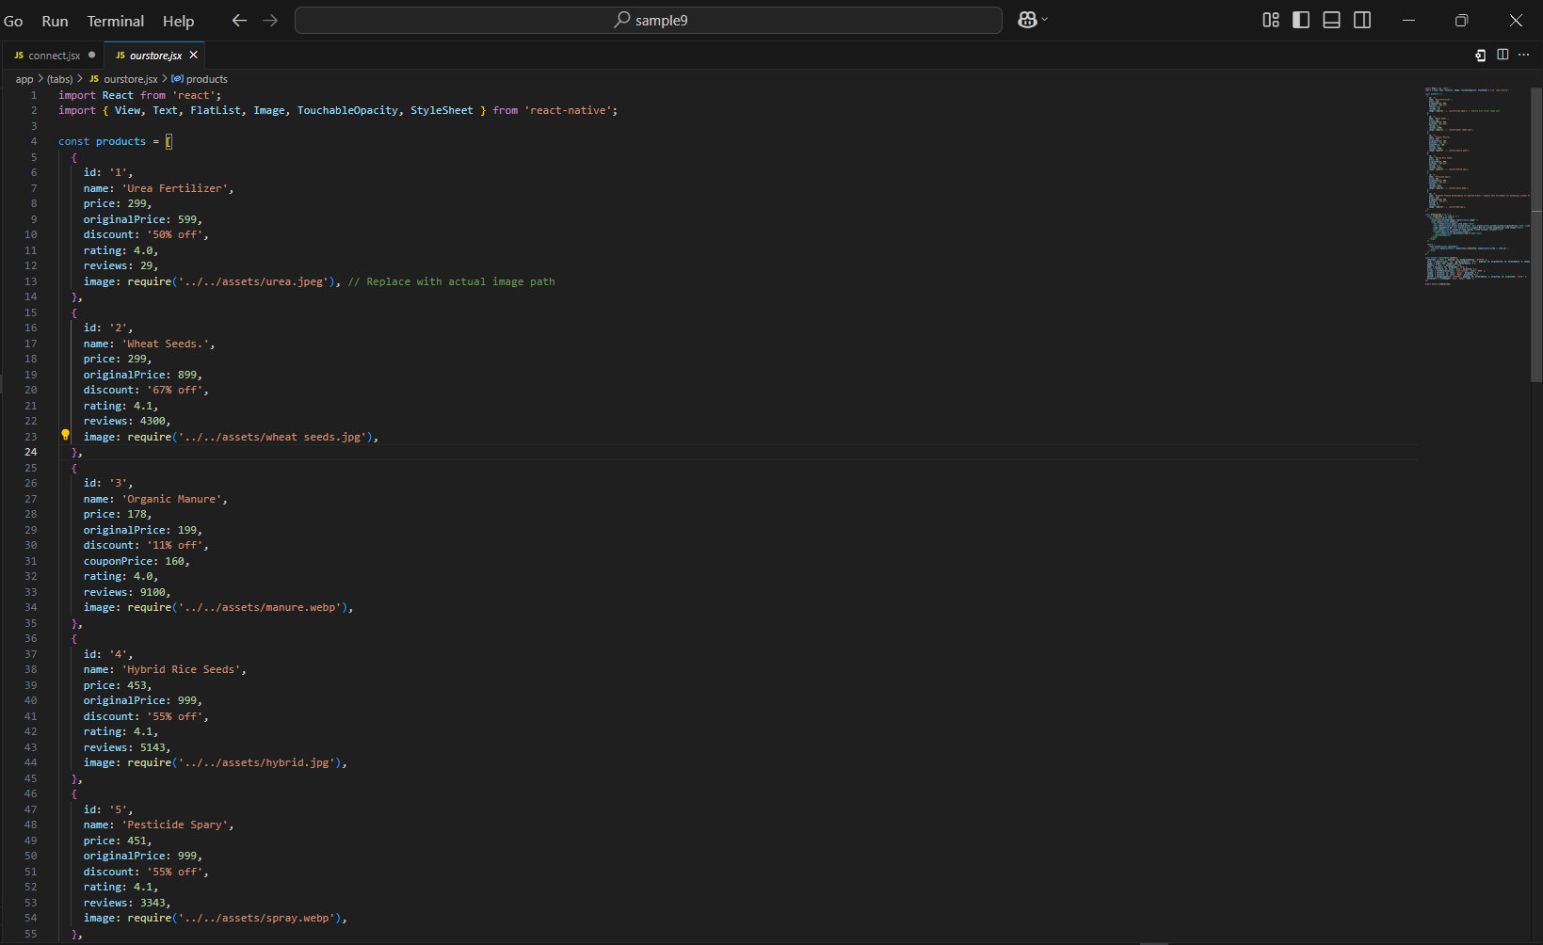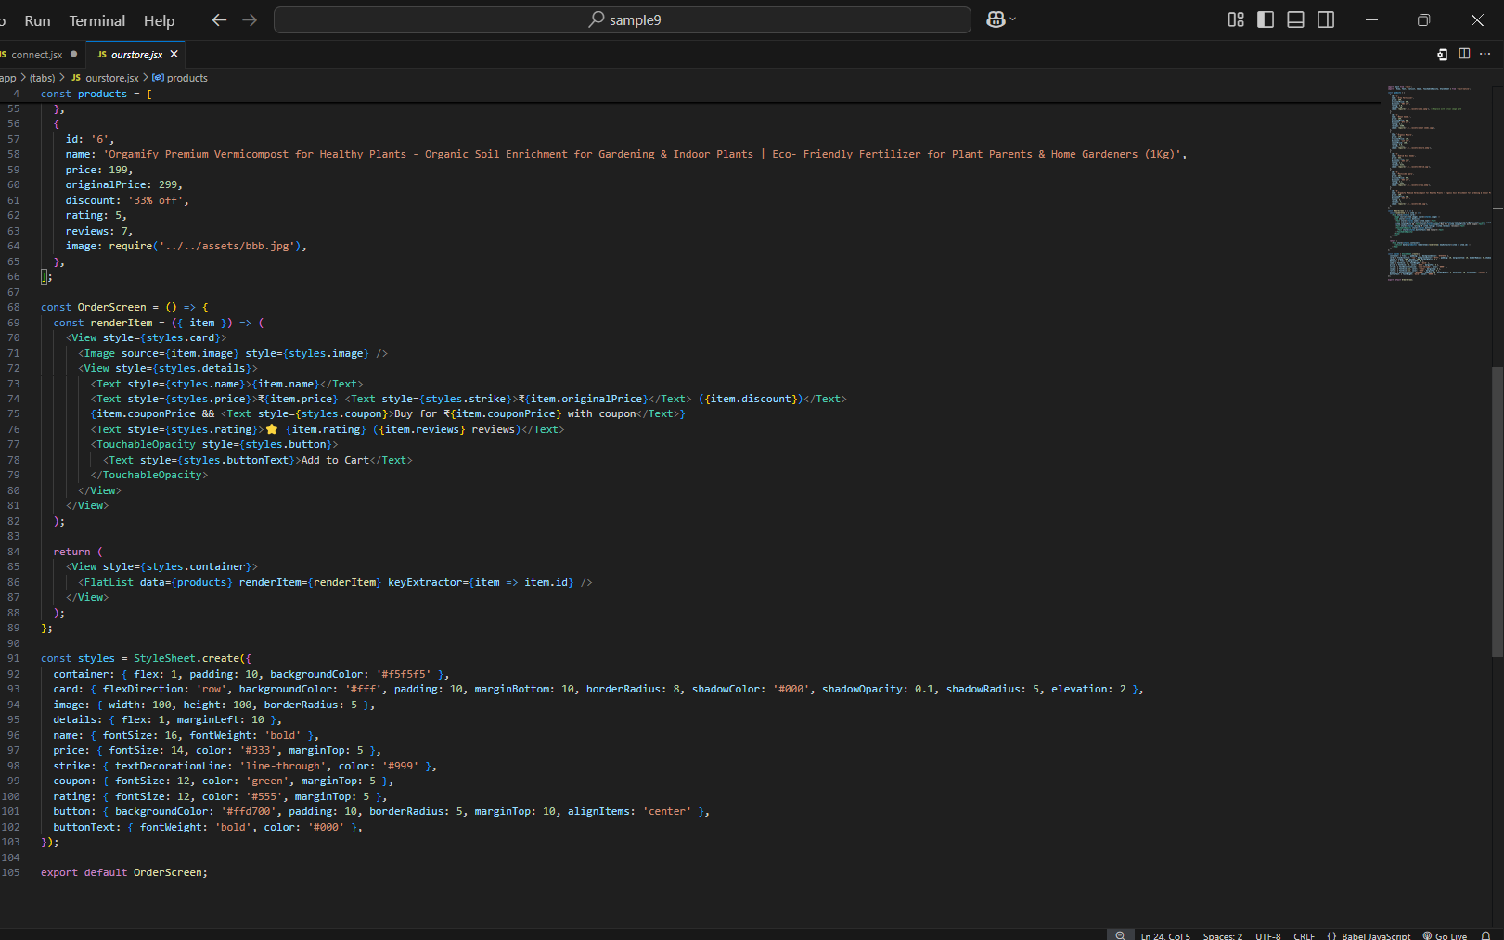

Your Order.jsx page!

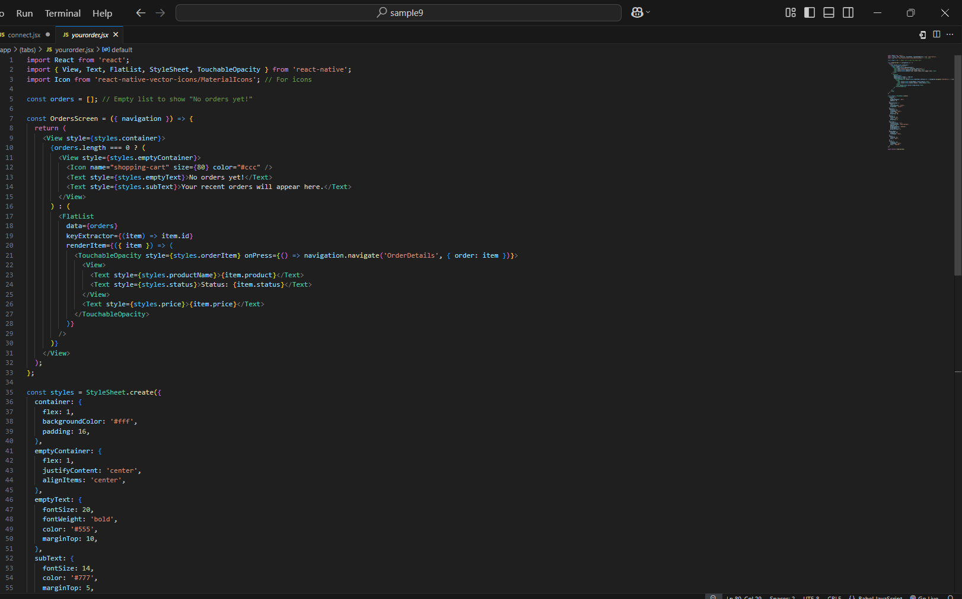


Drawer section help and settings.jsx page!

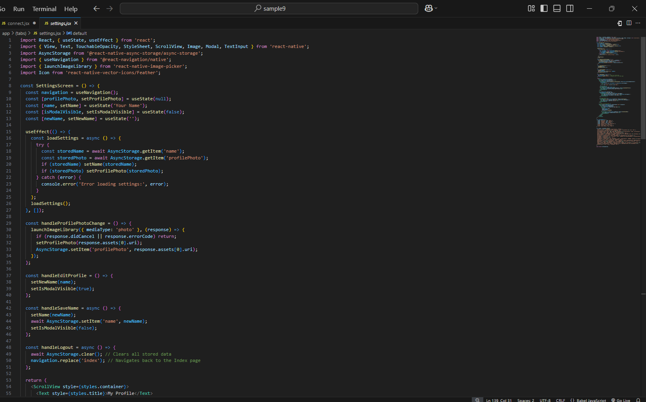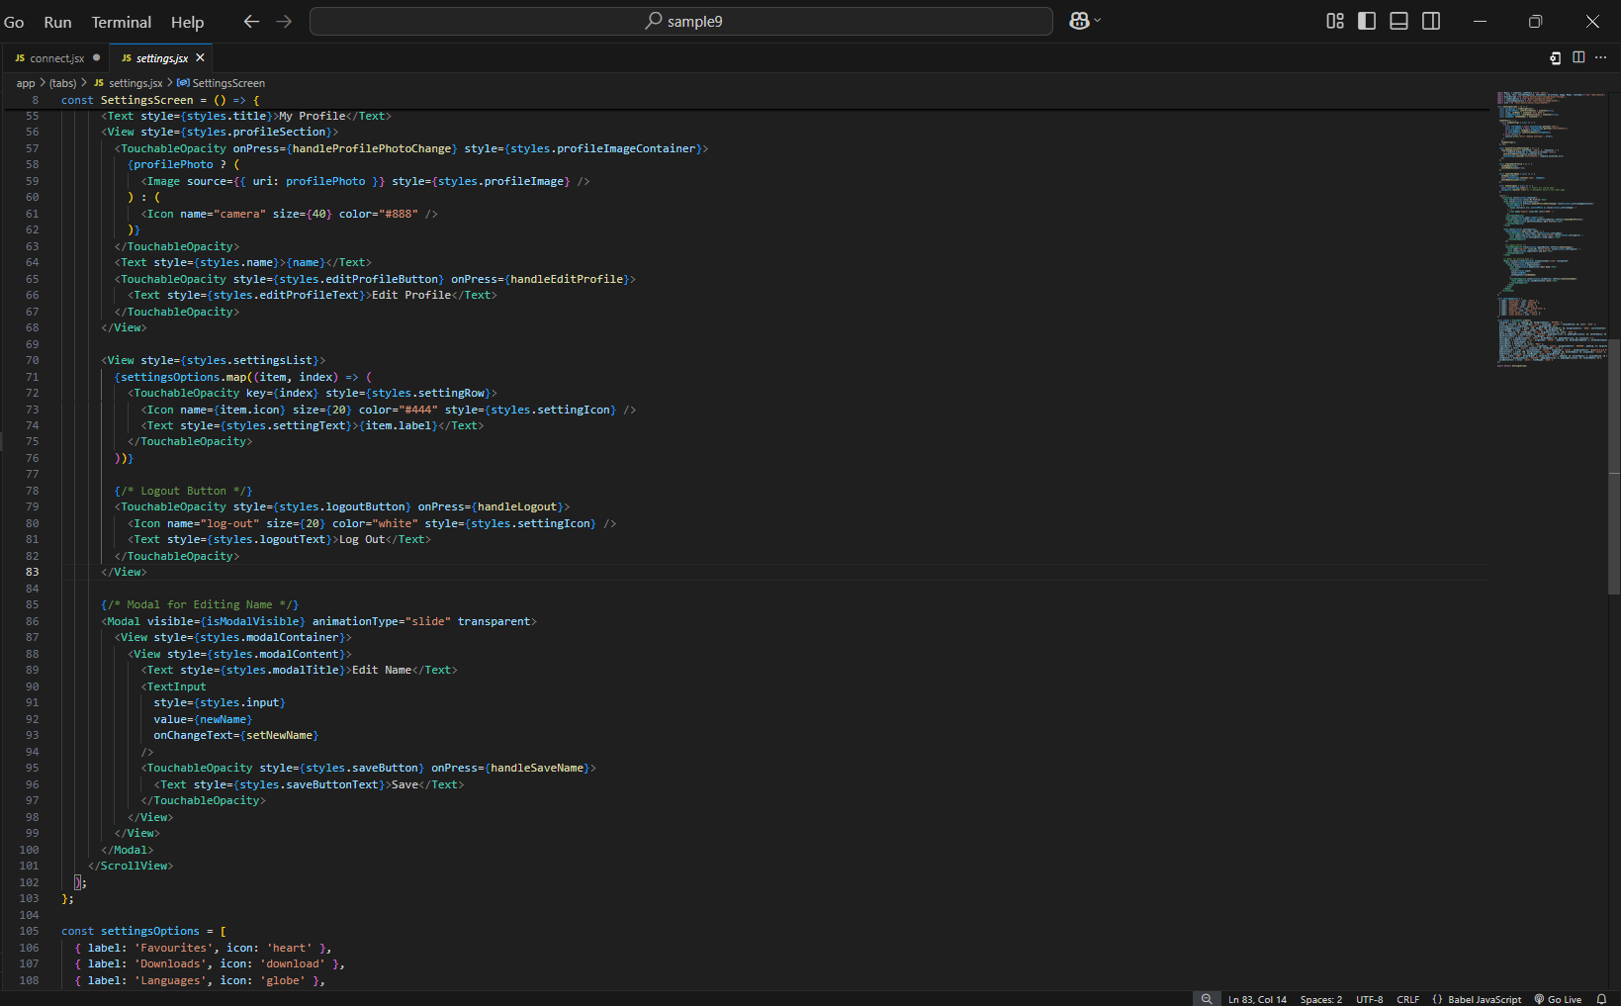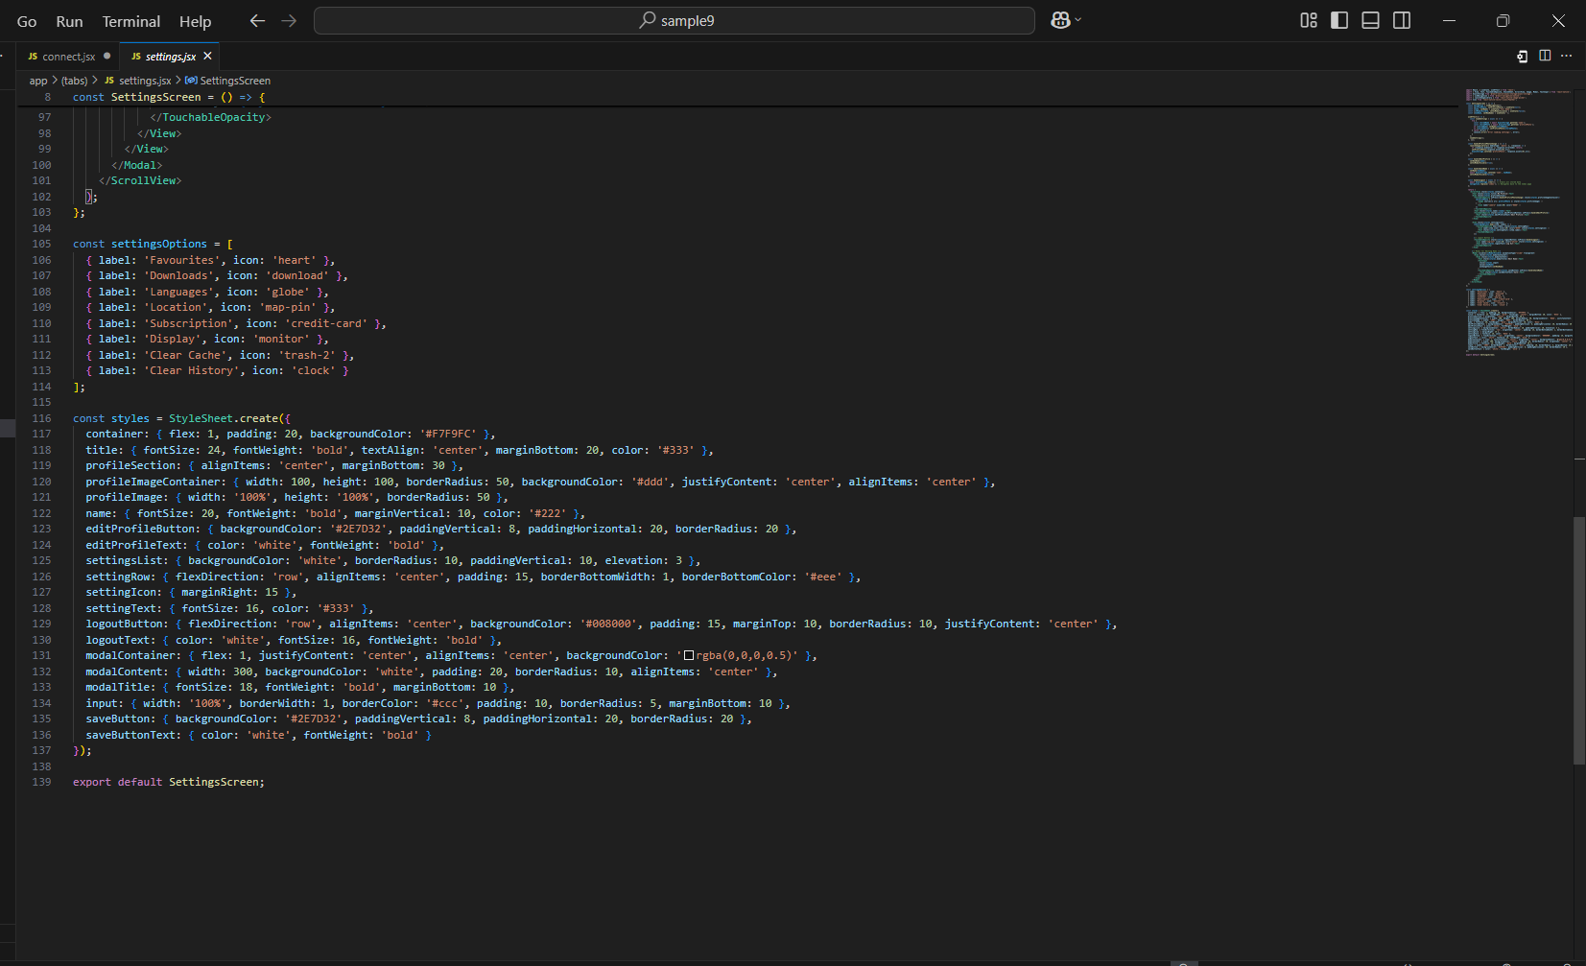

Help page

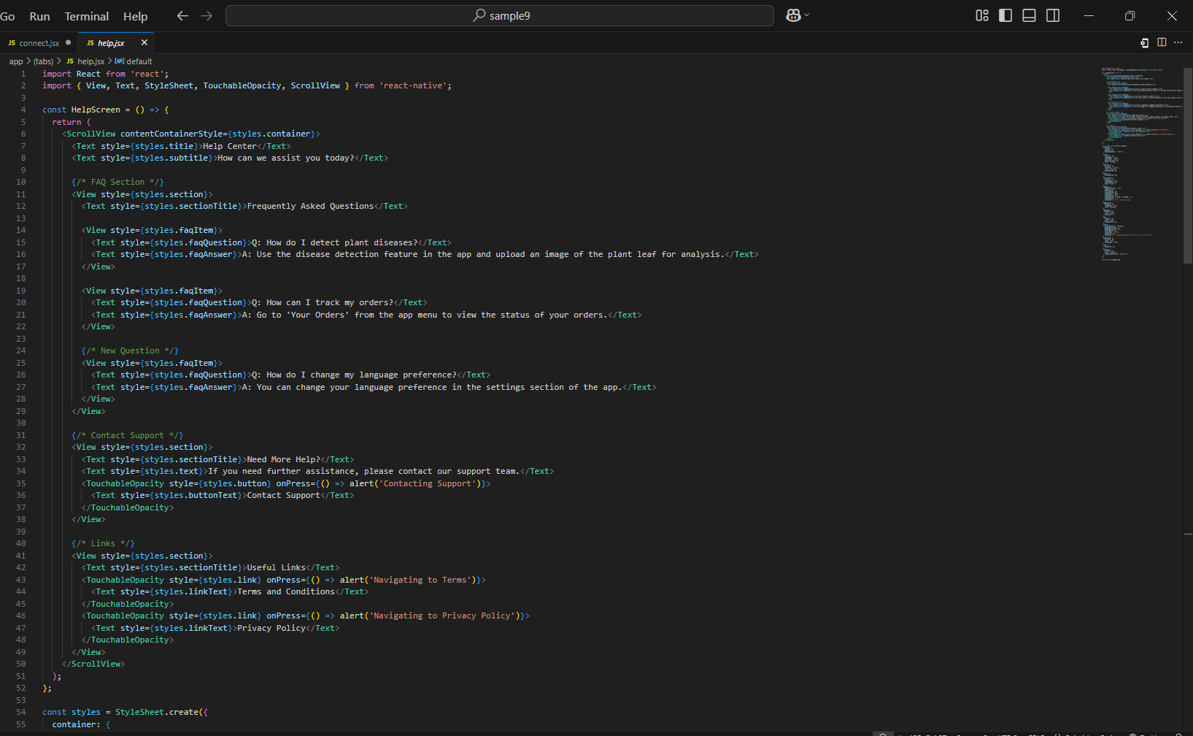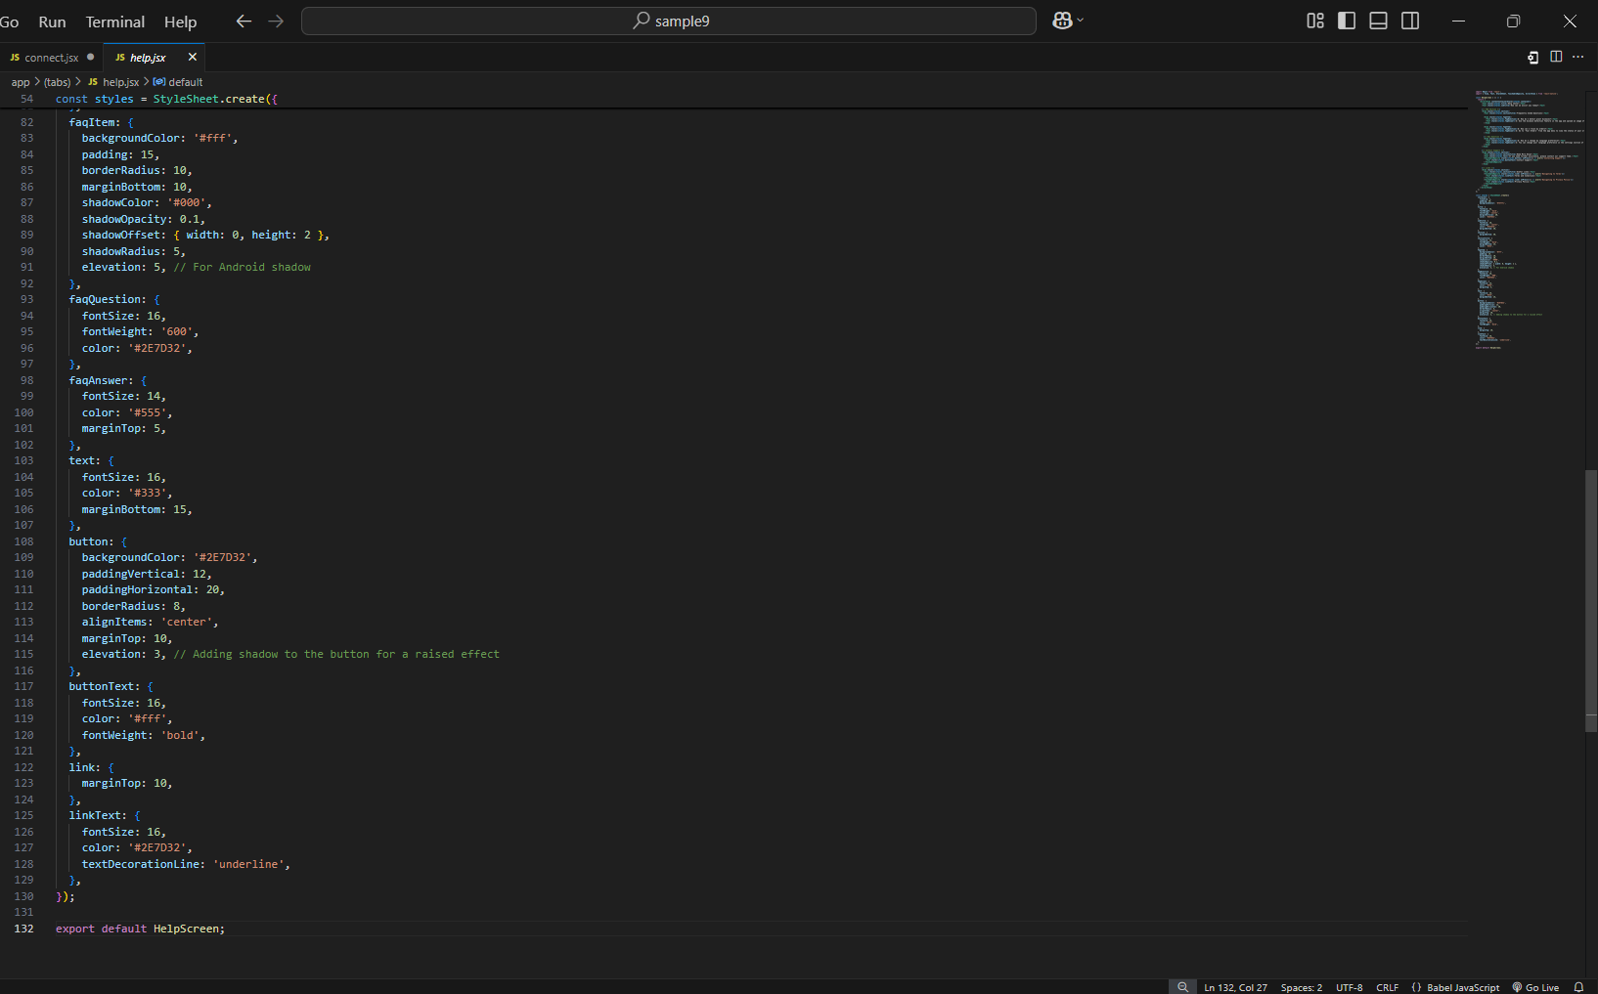

FireBase!!!

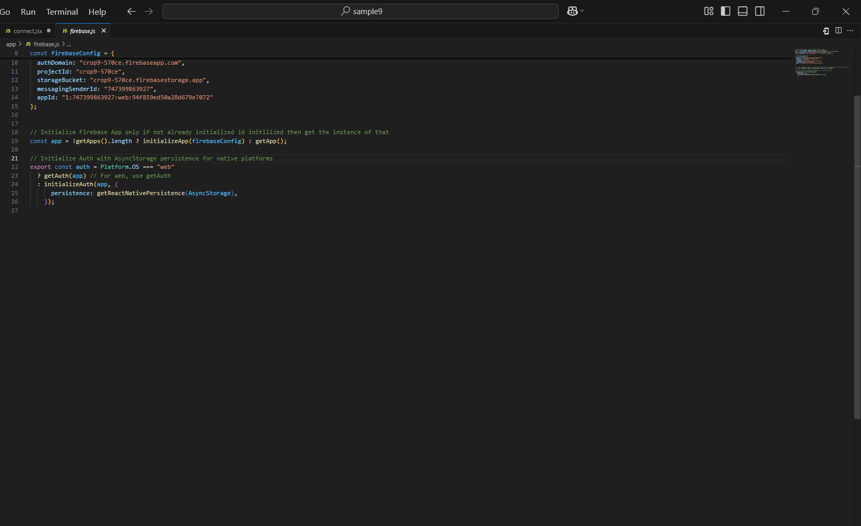

Output screens

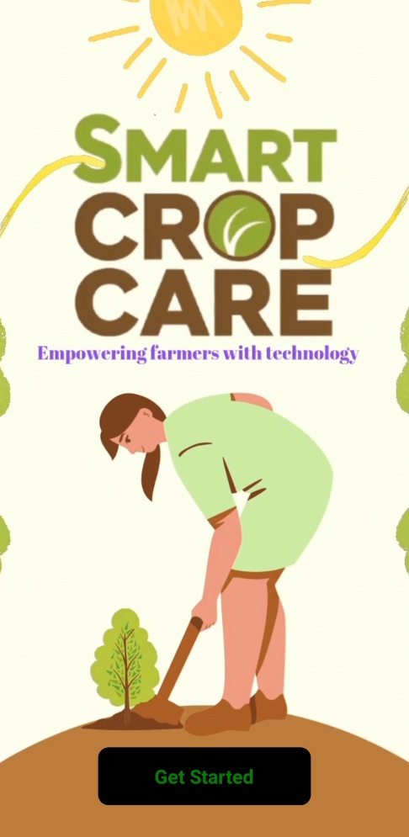

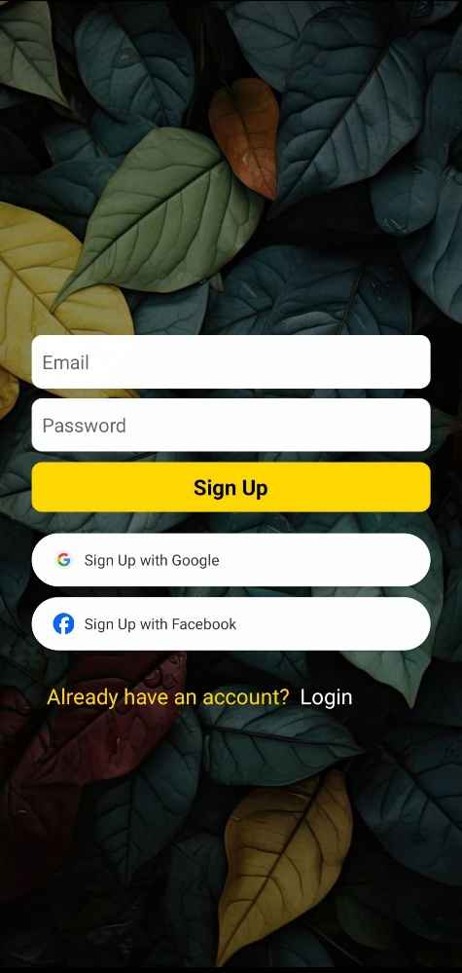

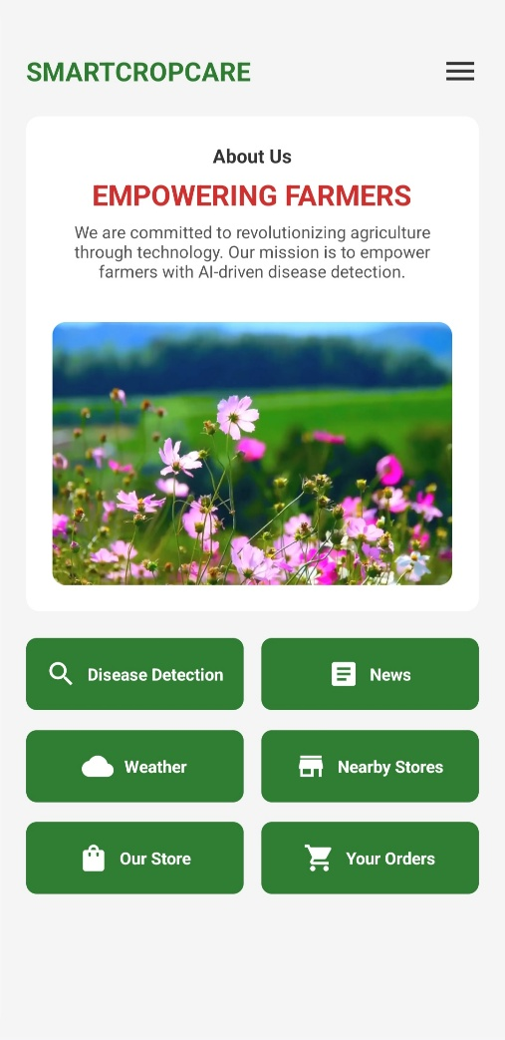
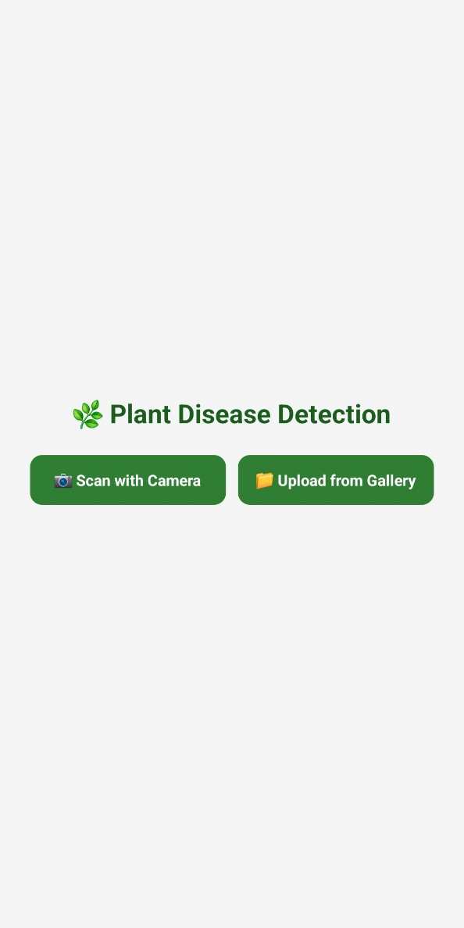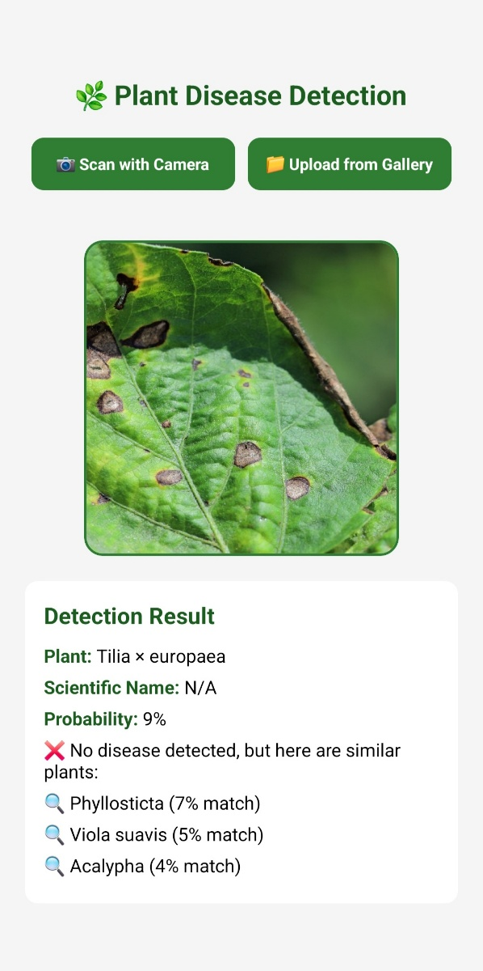
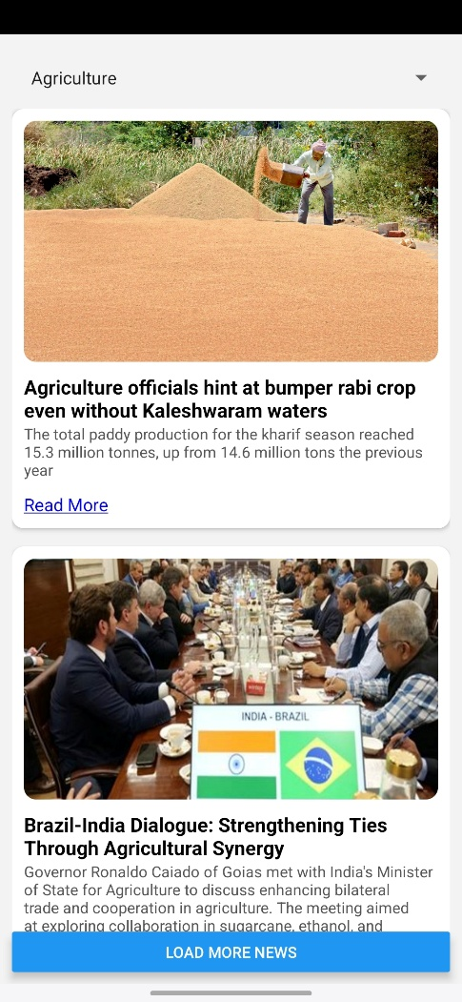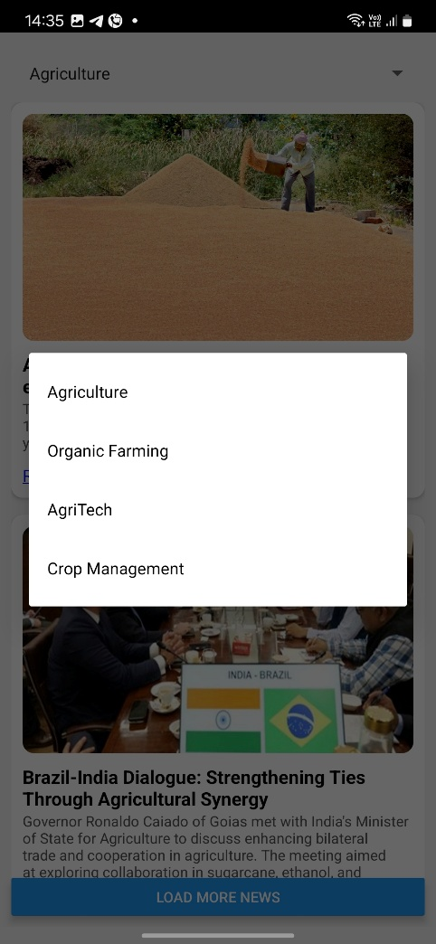

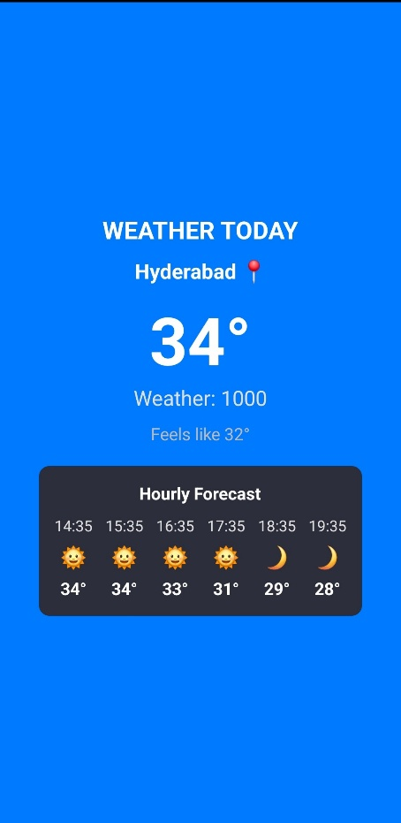

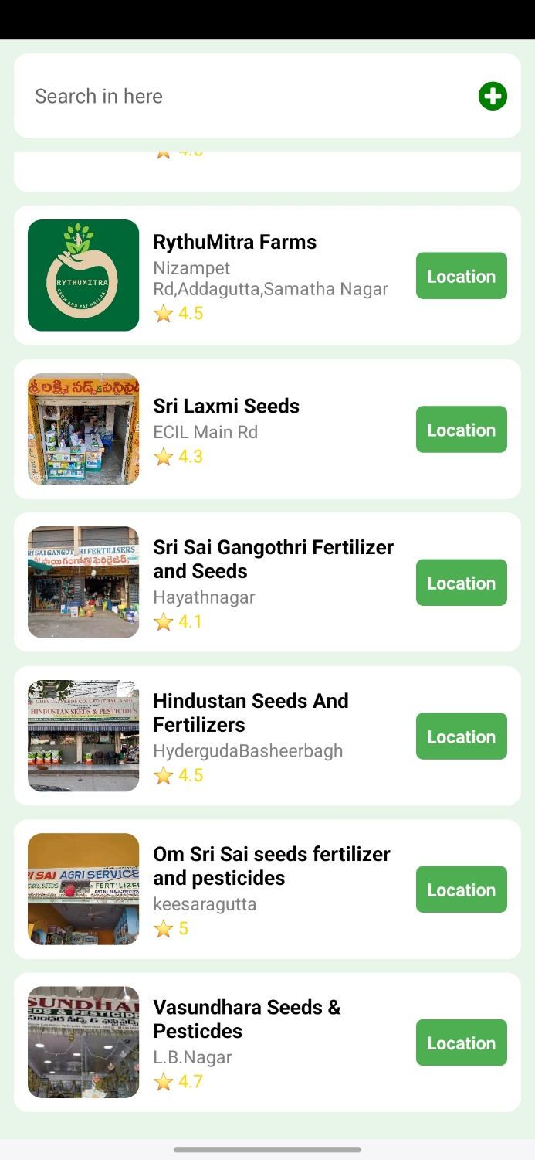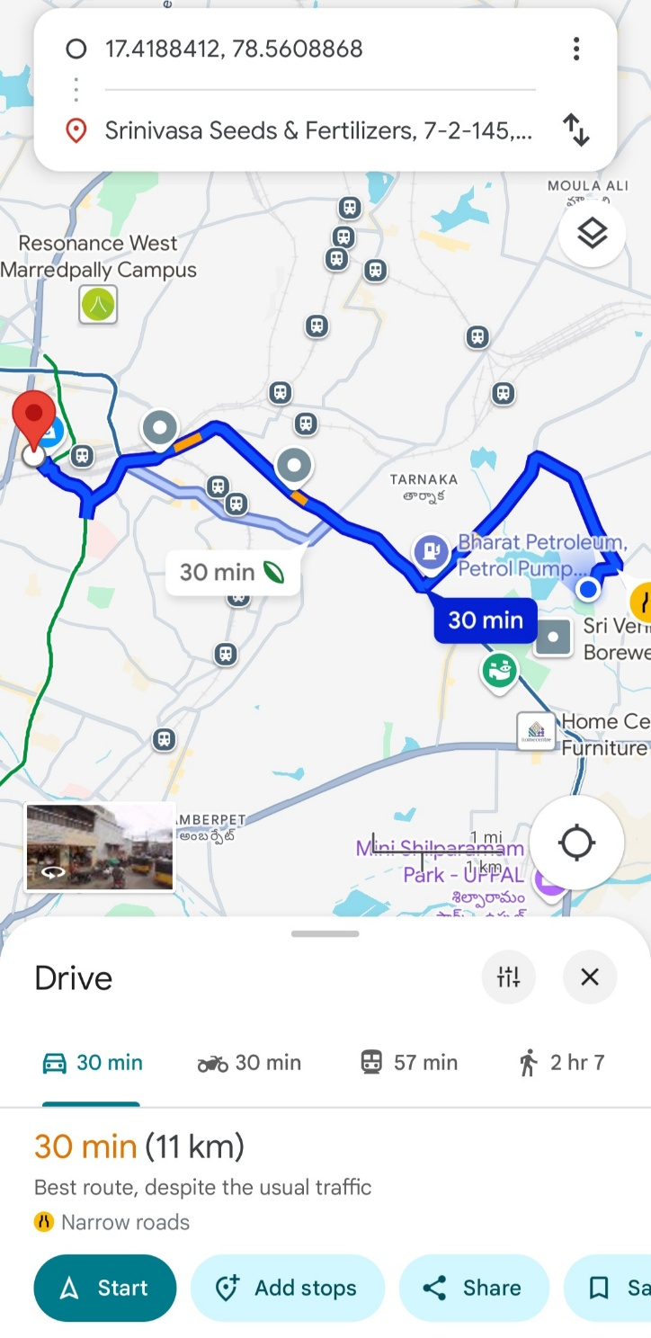

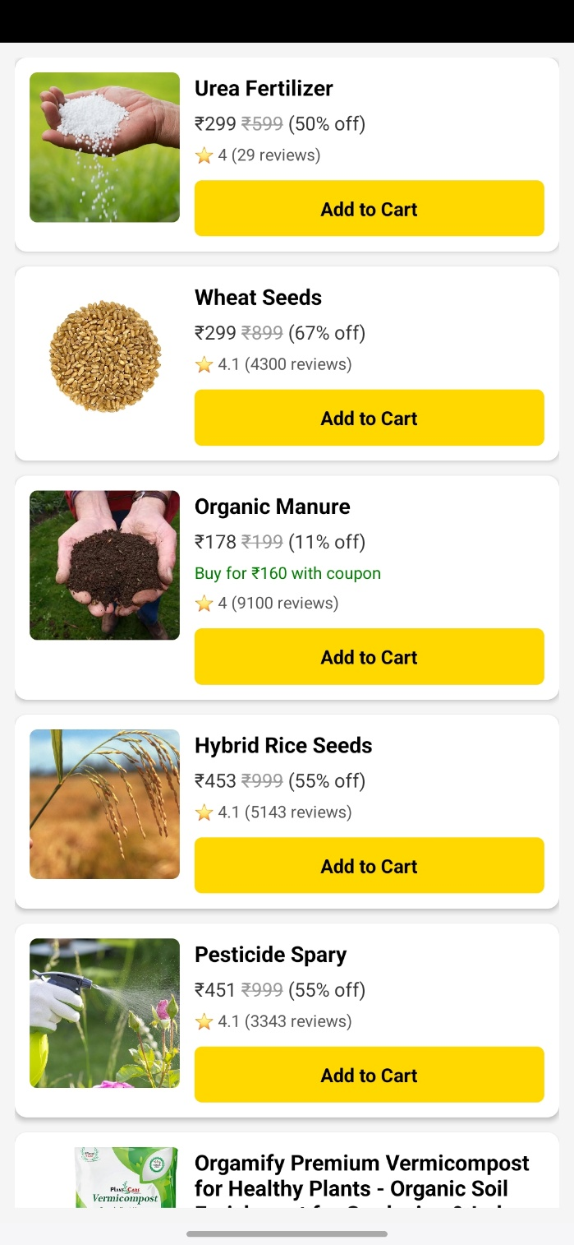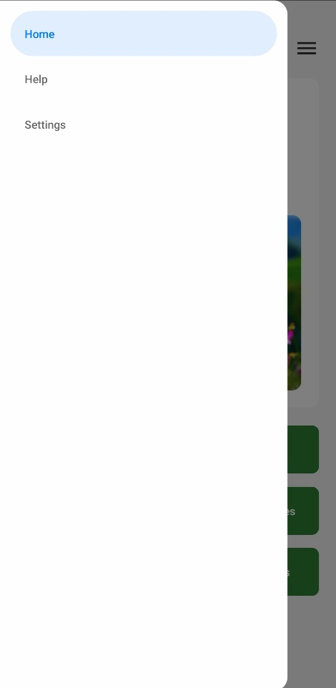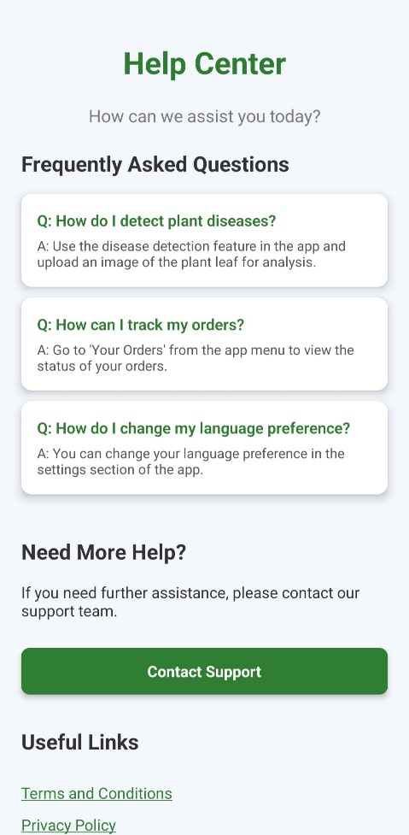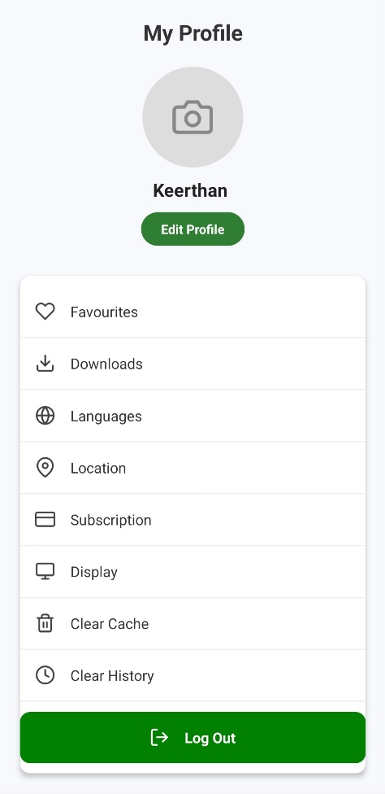

FUTURE SCOPE

1. Advanced AI-Based Crop Disease Diagnosis
- Improve disease detection with deep learning models for better accuracy.
- Integrate real-time image recognition for instant crop health analysis.
- Use AI to predict disease outbreaks based on weather patterns and historical data.
2. IoT Integration for Smart Farming
- Connect with IoT-based soil moisture sensors, temperature sensors, and drone surveillance.
- Enable automatic irrigation based on real-time soil conditions.
- Provide live farm monitoring via drones and smart cameras.
3. Personalized Crop Advisory & AI Chatbots
- AI-driven virtual assistant for farmers.
- Personalized fertilizer and pesticide recommendations based on soil tests.
- Multilingual chatbot for customer support & farming tips.
4. Weather-Based Predictive Analytics
- AI-powered weather forecasts and disaster predictions.

5. Augmented Reality (AR) for Smart Farming
- AR-based real-time guidance for farming techniques.
- Virtual soil testing and fertilizer application guidance through AR.
- Interactive AR tutorials for pest control and irrigation methods.

6. Government & NGO Collaboration
- Partnering with government schemes for subsidies and insurance.
- Integration with organic farming initiatives and sustainability projects.
- AI-driven policy recommendations for smart agriculture.
7. Sustainable & Precision Farming
- AI-driven precision farming solutions to reduce waste.
- Smart irrigation to conserve water.
- Encouraging organic and eco-friendly farming practices.

CONCLUSION

SMART CROP CARE is a revolutionary AI-driven Expo React Native application designed to empower farmers with technology, bridging the gap between traditional agriculture and modern innovations. By integrating AI-based disease detection, real-time weather updates, personalized fertilizer recommendations, an online marketplace, and customer support, the app enhances farm productivity, efficiency, and sustainability.
With future advancements such as IoT-based smart farming, AI-driven predictive analytics, blockchain for supply chain transparency, and AR-based farming guidance, SMART CROP CARE has the potential to transform agriculture into a more data-driven, precise, and eco-friendly industry.
By continuously evolving and integrating cutting-edge technologies, SMART CROP CARE aims to provide farmers with smart, accessible, and innovative solutions, ensuring better yields, reduced losses, and a more sustainable agricultural future. 🌱🚀

